**Introduction: analysing data from SoundTraps**

Authors: Jamie Macaulay and Susannah Calderan

DOI:

Last tested: 25/09/2024

PAMGuard version: 2.02.13b

The folder containing data is Introduction_static_monitoring/Data

Table of Contents

Introduction 2

Setting up the PAMGuard data model 3

A side note on full bandwidth files 20

Processing the data 21

PAMGuard viewer mode 23

Navigating the dataset 23

The time base display 30

Automatic classification 37

Exporting data 38

Summary 40

# Introduction

Static underwater recorders are a powerful PAM methodology, especially for investigating long term temporal trends. As batteries and storage have improved, underwater recorders can now collect months of high frequency raw acoustic data. The advantage of such data is that, as well as the ability to detect any vocalising species covered by the Nyquist frequency and hydrophone sensitivity, a host of other metrics of the soundscape are available such as ambient noise, spectral complexity, anthropogenic sounds etc. The disadvantage of recorders is the high data volume, and complexity of analysis. PAMGuard attempts to address both these problems, first by providing tools with a graphical user interface to run the large number of complex signal processing algorithms used in acoustic data analysis and secondly by allowing users to save “first run” analysis results in a file format which can compress the data up to 99.9%. The first run results consist of basic acoustic metrics such as noise in different frequency bands and/or high false positive rate detector data, such as detection of clicks or whistles and moans. The high false positive data has the advantage that it identifies all the interesting sections of data, even if many of those data are not actually the target species. PAMGuard then provides an analyst with highly interactive displays to manually annotate the data and/or allows a user to run further automated classification algorithms that can automatically detect different species.

In this exercise we will learn how to analyse data from a SoundTrap static recorder and click detector. SoundTraps can record full spectrum 576kHz sound files capable of detecting the full range of cetacean vocalisations. These files are very large and limit the recording time of the device. However, apart from echolocation clicks, most cetacean vocalizations, such as whistles and moans, are less than 30kHz. SoundTraps therefore have the ability to record at lower sample rates whilst also running a high frequency (576kHz Nyquist) click detector to pick up higher frequency echolocation clicks. This greatly increases recording time without losing too much acoustic information.

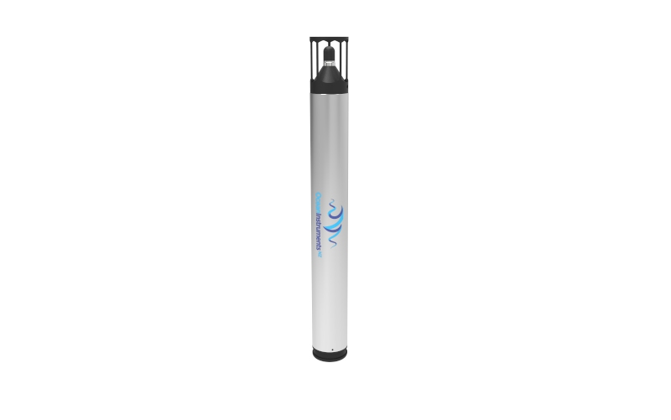

*Figure 1. A SoundTrap ST600. As of 2024, these are the best performing and most advanced marine acoustic recorders available and they are priced as such.*

In this exercise will first set PAMGuard up to import the clicks detection and raw sound files recorded on the SoundTrap and then run through extracting a series of acoustic metrics and running several detectors at high false positive rates. We will then review the processed data, demonstrate how to visualise different aspects and do some basic automated click classification. Finally, we will export a subset of the data to be used in further analysis outside PAMGuard.

*Note*

*In marine bioacoustics acoustic data analysis to automatically detect species tends to be split into detection and classification processes. Detection generally refers to an algorithm that picks out any sound that might be biological in origin. Unless a dataset is particularly devoid of other sounds, then often a detector will run at a high false positive rate i.e. many of these sounds will not be the species of interest. The classification process then runs through the detection results and attempts to identify whether a detection is a particular species or not. A good example of this is the PAMGuard click detector. The PAMGuard click detector picks out short sharp sound with defined frequency limits. Most short sounds are ambient and/or anthropogenic noise, , however a subset will be echolocation clicks from sperm whales, dolphins, beaked whales or porpoises. The transient data saved by PAMGuard is very detailed. Waveforms are saved which allow additional classification algorithms to identify whether a detected transient might be an echolocation click and what species it might be from. However, although the transient data are very detailed they are often only 0.1% the size of the original wav files.*

*Why are things organised as detection and classifications? One good reason is that detection data are much easier to handle than raw .wav files. Classification algorithms run much faster on a few hundred megabytes of detected transients than a few terabytes of raw acoustic data. Other than that, the distinction is in many ways quite vague.*

# Setting up the PAMGuard data model

First make sure that PAMGuard 2.002.03 is installed. Open PAMGuard (Normal mode). When prompted, create a new. psfx settings file. Name it and save it somewhere sensible You will be presented with a blank canvas.

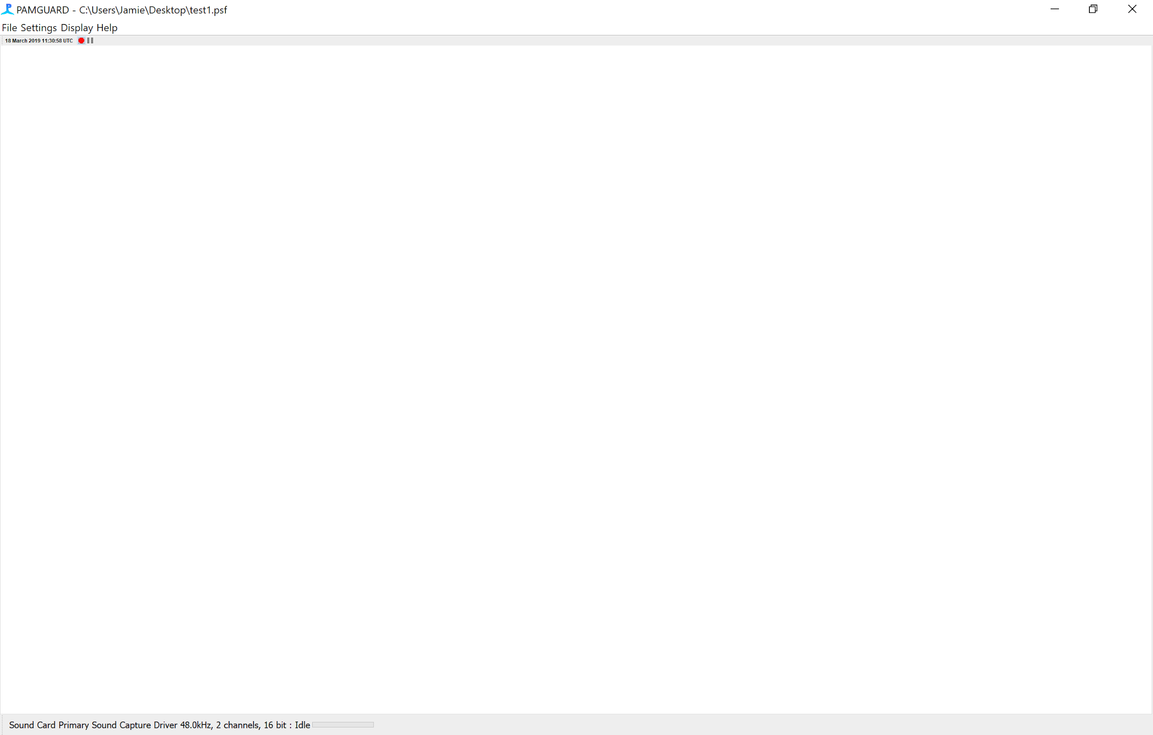

*Figure 1. When PAMGuard is first started it is essentially a blank canvas. You have to add modules to construct an acoustic workflow – this is called the “data model”.*

PAMGuard is a modular program. i.e. you have to tell it what you want it to do, and what algorithms you want run by adding specific modules for each signal processing/detection task. The first module we need is a module which acquires the acoustic data from the device. Click ***File-> Add Modules -> SoundProcessing -> SoundAcquisItion****.*

The sound acquisition module will now have been added. Click ***Settings->Sound* *Acquistion*.** In the drop down. In the ***Data Source Type*** drop down menu select ***Audio file folder or multiple files*.** Now click ***Select Folder or Files*** and browse to the folder (named ***audio***) containing sud files (SoundTrap data files) for this exercise.

*Note: Sud files contain metadata, detection data and compressed audio from SoundTraps. SoundTrap host software can decompress sud files however this can increase the size of the dataset by up to four times. PAMGuard can now read sud files directly which means, in many cases, there is no need to decompress them, saving time and a lot of hard disk space!*

The peak to peak voltage range of a SoundTrap is 2V. Enter this in the Peak to Peak voltage range box to make sure PAMGuard calibrates acoustic measurements properly i.e. to ensure that received amplitudes in dB are correct. Click OK.

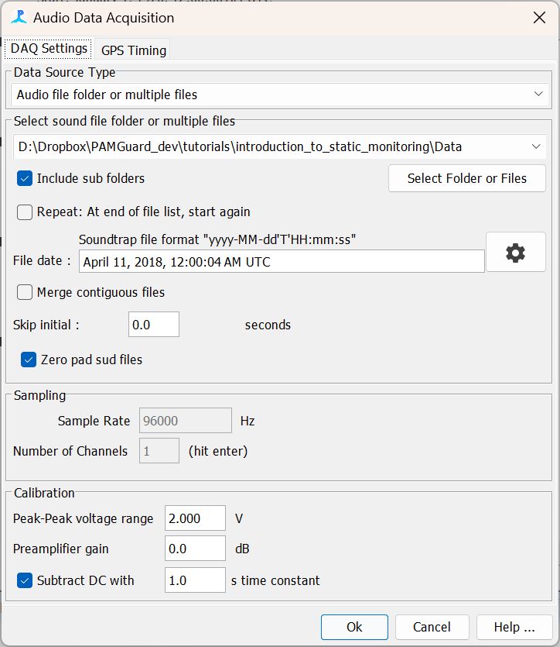

*Figure 2. The Sound Acquisition module after it’s been set up to import SoundTrap recordings. Note that PAMGuard reads the xml files of SoundTraps for file time (if they are available).*

Now that the Sound Acquisition module is added PAMGuard knows the sample rate and number of channels of the data to be processed. This will make setting up the next modules easier by ensuring that PAMGuard initially uses sensible default values for each new module. Many of the detector modules require Fast Fourier Transform (FFT) data. The next stage is therefore to add an FFT module. Click ***File-> Add Modules -> Sound Processing -> FFT (Spectrogram Engine)*** to add the FFT module. Open the module settings by selecting ***Settings ->******FFT (Spectrogram Engine) settings…***

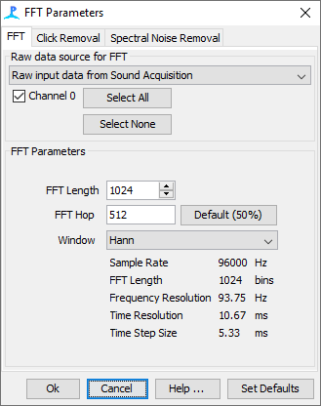

*Figure 3. The settings for the FFT (Spectrogram) Module.*

The default settings for the FFT module are fine. Note though, that the FFT module is a very powerful signal processing toolbox with ability to remove clicks and spectral noise. If running detectors on FFT data, this can help improve detection efficiency.

Next, we will add a Whistle and Moan detector to detect any tonal sounds, usually whistles from dolphins. This detector works from FFT data but has its own signal FFT noise reduction process. Click ***File-> Add Modules -> Detectors -> Whistle and Moan Detector****.* Open the modules settings by clicking ***Settings-> Whistle and Moan Detector*** The module will need a bit of setting up. First tick ***Channel*.** Make sure ***Max Frequency*** is 30000 Hz. Next click the Noise and Thresholding Tab and select all the tick boxes leaving other settings at default.

*Figure 4. Settings for the Whistle and Moan Detector module. Note that Noise and Threshold are very important for the contour tracking algorithm to work properly*. 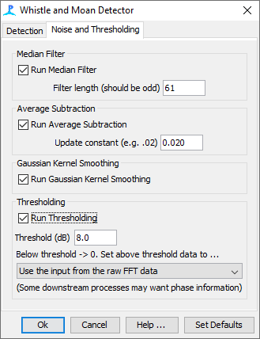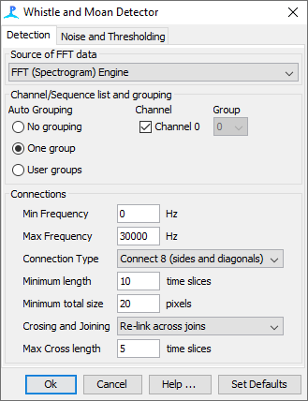

A description of each parameter used the Whistle and Moan Detector is discussed in detail in the ***Help*** files.

Now we have a very simple but working configuration. ***Click File -> Show Data Model*** to view the data model. This is an interactive visualisation of how modules are organised and which data sources they are connected to. Here you can see that the raw sound data is passed to an FFT module, where it is converted into FFT data. The FFT data are then passed to the Whistle and Moan Detector module where a detector looks for tonal sounds. 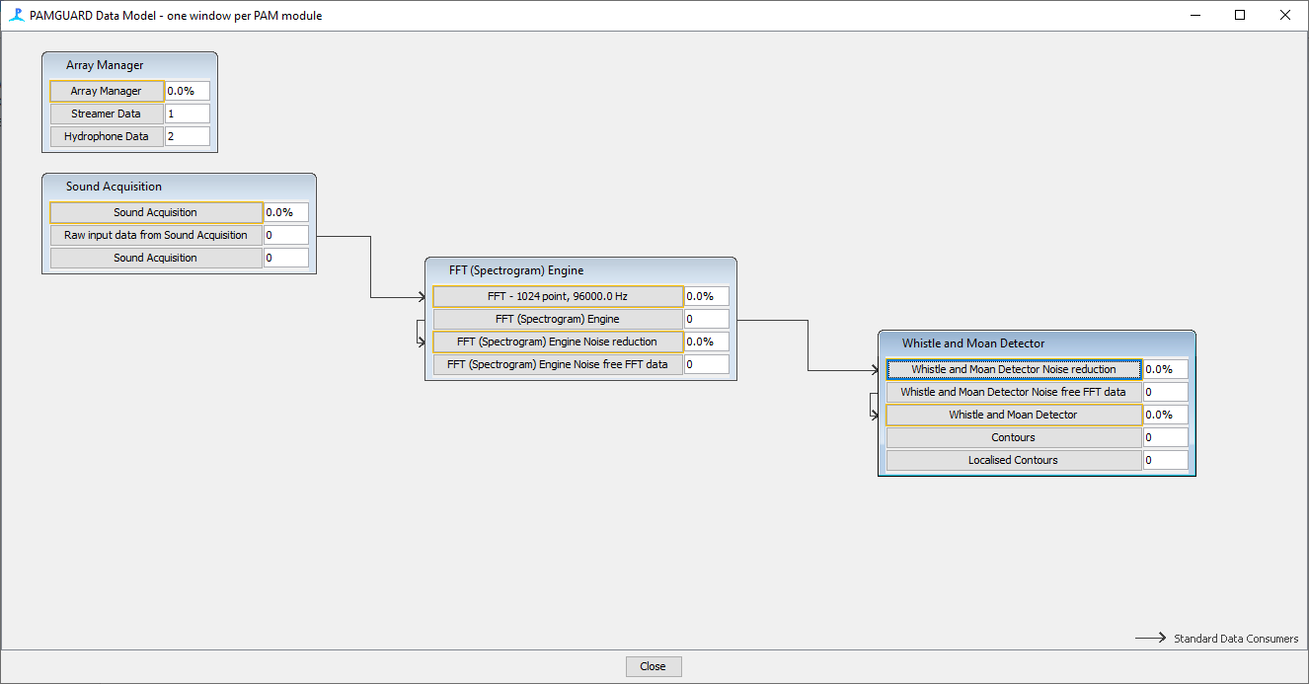

*Figure 5. The data model so far. Note how the arrows show the direction of the acoustic workflow – i.e. raw sound from The Sound Acquisition module is converted into spectrogram data by the FFT Module and the spectrogram data is then processed by the Whistle and Moan detector module.*

Currently this configuration will run, however there are no displays to show the detector and spectrogram (FFT) data. To create a display, we will add a display tab. Click ***File -> Add Modules -> Displays -> User Displays*.** This will add a tab.

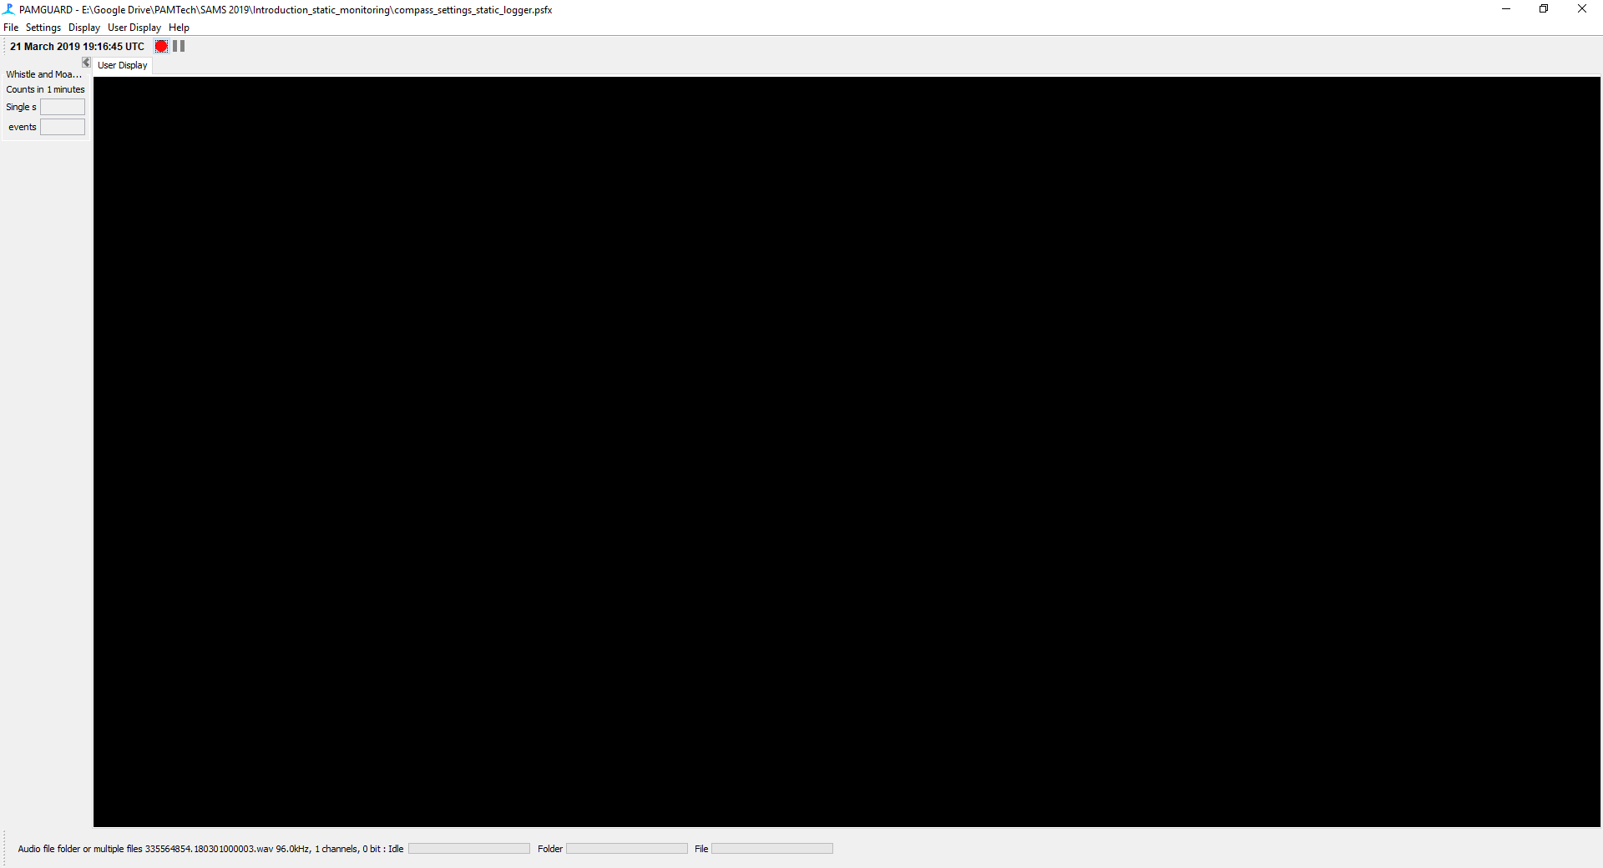

*Figure 6. Users displays are added to PAMGuard to create a new tab in which different types of displays e.g. spectrogram, map, radar, time base display can be added.*

The tab can contain multiple displays of different types. In this case we only want a spectrogram. Click ***User Display -> New Spectrogram Display*.** A dialog box will appear Change the ***Number of Panels*** to 1 and hit Enter.

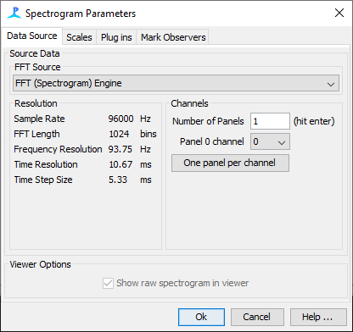

*Figure 7. Parameters for the spectrogram display.*

The spectrogram display will now be added. The spectrogram display shows FFT data but also allows users to see overlay data from different detectors. As we are using a whistle and moan detector it is a good idea to overlay the detected contours. Right click on the spectrogram and click the cog in in the ***Contours*** option. Make sure that ***Enable*** is selected and ***Max frequency*** is set to 30000 so the contours appear on the spectrogram.

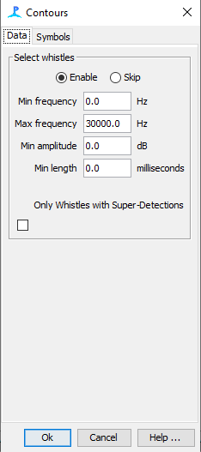

*Figure 8. The data selector menu allows users to filter the detected whistles plotted in the spectrogram.*

Now we can visualise data. Click ***File -> Save*** to save settings and press the red “go” button. You should see PAMGuard processing spectrogram data. If you look long enough blue contours should appear when a tonal sound is detected.

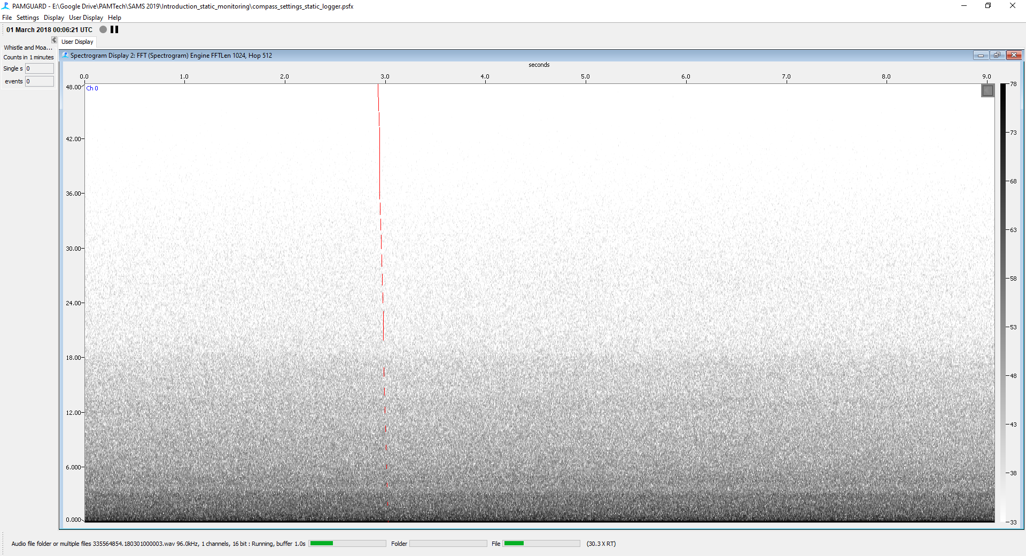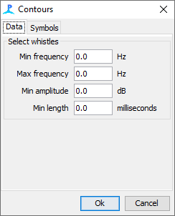

*Figure 9 PAMGuard running through the sound data and showing a spectrogram.*

Once you have had enough looking at the processing display press the pause button. At the moment PAMGuard is doing nothing but processing the data. It is not saving any results from the detector. This type of configuration could, for example be useful for real time monitoring on a boat, however here we obviously wish to save our results.

PAMGuard saves data in two ways, using a database and custom “Binary” files. The database holds information such as GPS data, settings and noise data. Ideally PAMGuard would only use one type of storage, however detector data, such as clicks and whistles/moans, especially for large datasets, can be substantial in size, up to tens of gigabytes. This volume of data slows down databases which is why PAMGuard uses a much more efficient storage system, Binary files. Although Binary files are much faster, they are not human-readable like databases and so require software libraries to open them.

Add both the database and binary storage options to PAMGuard. Click ***File-> Add Modules -> Utilities -> Database***. Click ***File -> Database -> Database Selection …*** Click ***Browse/ Create...*** and select a location and name for your database (make sure it’s somewhere you can find it again).

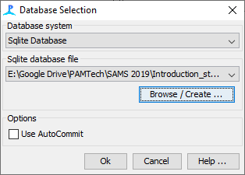

*Figure 10. The database settings dialog. This allows uses to select a database file which PAMGuard uses to save metadata.*

Next add the binary storage**. *File -> Add Modules -> Utilities -> Binary Storage*.** You will need to specify a *folder* that the binary files will be written to. Click ***File -> Binary Storage Options…***

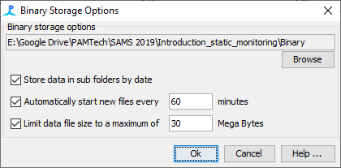

*Figure 11. The binary file storage dialog. Binary files store detection and soundscape data e.g. detected whistles and moans etc.*

In the Binary Storage Options dialog box click ***Browse*** and select a storage folder. Again make sure you remember the location (usually it’s sensible to put the binary folder in a parent folder also containing your database and .psfx settings file).

If you click ***File -> Storage Options*** you will now see that ***PAMGuard*** has selected which data outputs will be saved to which type of storage.

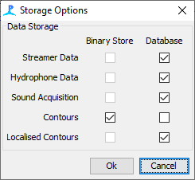

*Figure 12. the storage options dialog. Storage options is a manager that allows users to define which data are saved to the database and which data are saved to binary files. It is best to leave this as default.*

Only the whistle contours are currently saved to the binary files, however this will change as we add more detectors. Save your configuration.

We now have a working analysis configuration. However, it only detects contours and there are plenty more detectors and acoustic analyses PAMGuard can perform. In the next stages we will add a Long Term Spectral Average, Noise, and low frequency Whistle and Moan Detector to help pick out sonar and baleen whales.

A long-term spectral average (LTSA) is an excellent way to visualise a sound scape over long time periods. An LTSA is essentially a spectrogram which can be viewed over long time periods. It allows a manual analyst to quickly glance at long time periods and pick out interesting sections of data and is useful in pretty-much every analysis configuration. To add the LTSA module click ***File-> Add Modules -> Sound Processing -> Long Term Spectral Average.***

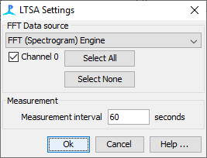

*Figure 13. long-term spectral average settings.*

Open the LTSA settings by click ***Settings->Long Term Spectral Average*…** and ensure Channel 0 is ticked. A measurement time of 60 seconds is fine.

Noise measurement is extremely important in PAM analysis. Noise levels change the probability of detecting cetaceans and so are essential in defining monitoring effort. For example, if a recorder picks up more animals at certain states of the tide, is that because there are more animals or there’s less noise at certain states of the tidal cycle? Unfortunately, noise is quite a complex thing to measure and how you measure it often depends on your question…there are entire courses on this! PAMGuard has a few handy noise modules that do a lot of the work for us. In this case we’ll measure octave bands using a filter bank with standardised filter settings.

Add the filtered noise module. ***File -> Add Modules -> Sound Processing -> Noise Band*** Monitor.

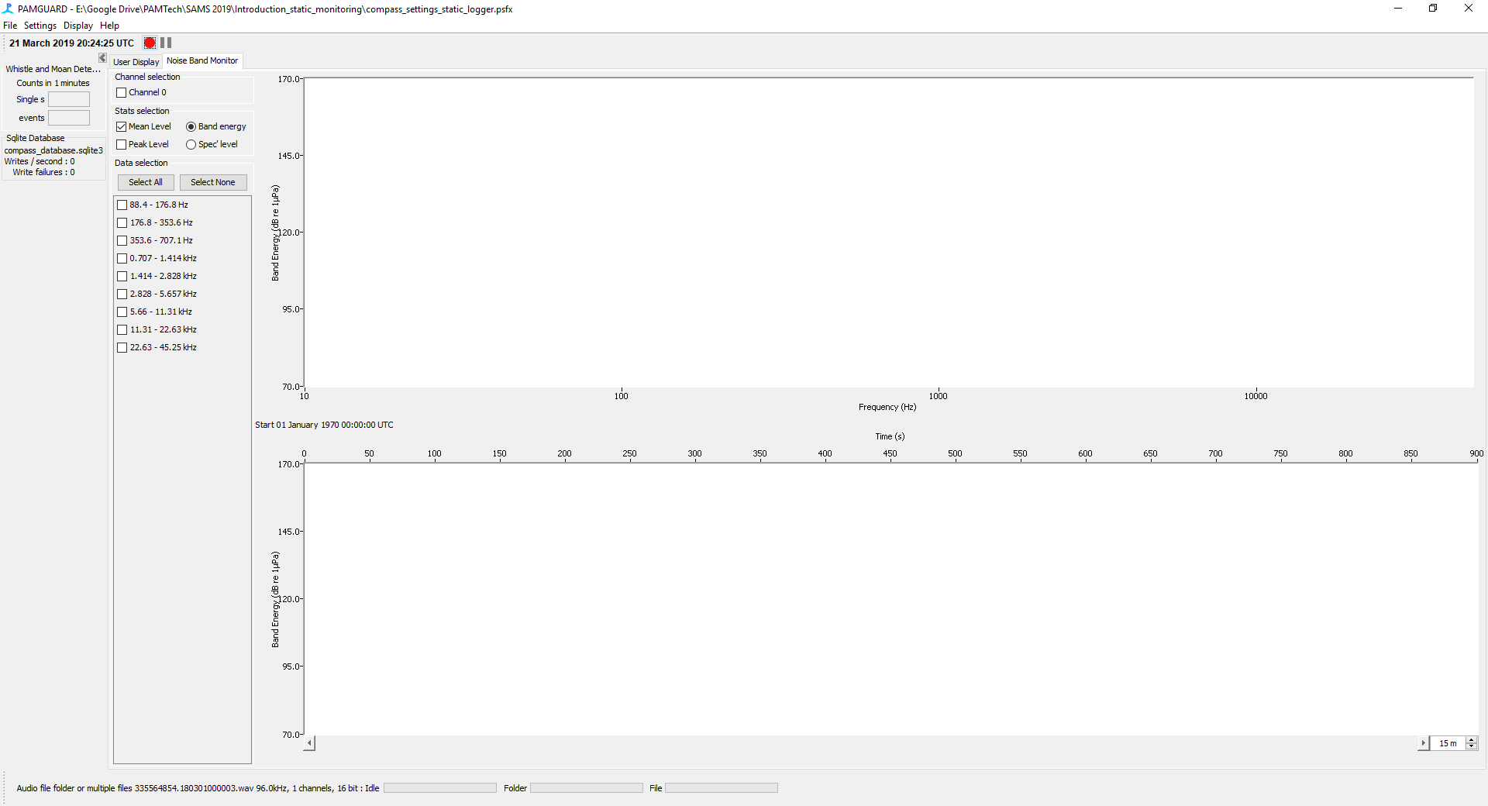

*Figure 14. The noise display in PAMGuard.*

This adds its own noise display. Click ***Settings ->******Noise Band Monitor***… to open the noise measurement settings. You will be prompted to select the raw data source.

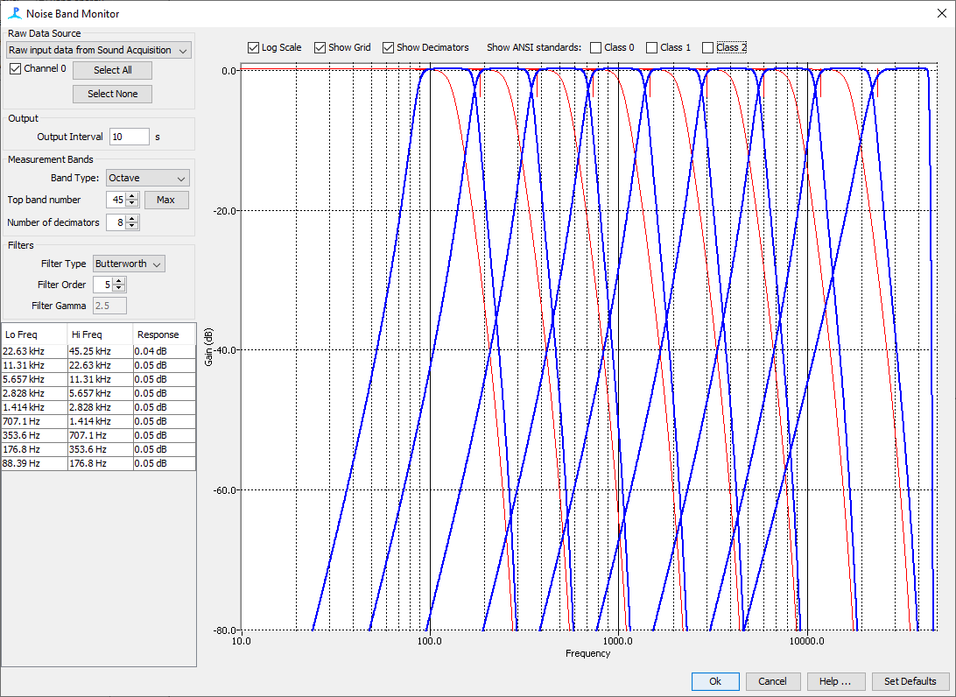

*Figure 15. Noise band settings. This allows the user to define which octave/third octave noise bands to process.*

We will be taking only Octave measurements. In ***Band Type*** select ***Octave*** instead of ***Third Octave.*** Click ***Max*** to fill all bands up to the Nyquist frequency. Click Ok.

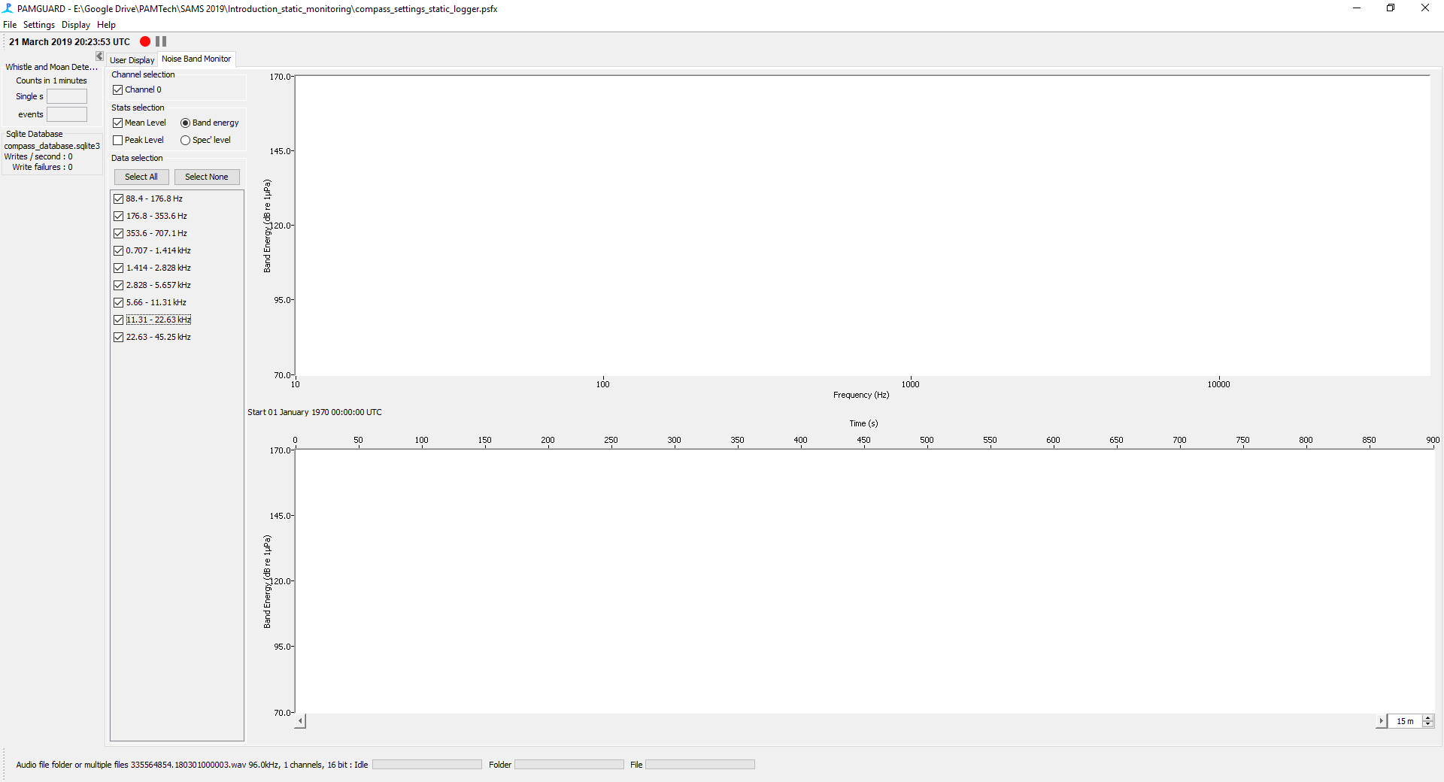

*Figure 16. The noise display after things have been set up for octave band measurements.*

You will notice that the Noise Band Monitor display now has tick boxes for all the different noise bands. Select these and make sure Channel 0 is also selected.

If we go back to Storage options in ***File->Storage Options*** you will notice that there are now three data streams saving to binary files, the LTSA, Noise Band Monitor and Whistle and Moan Contours.

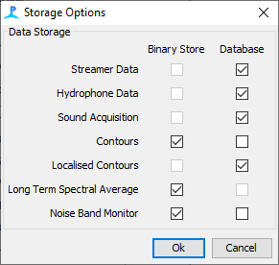

*Figure 17. Storage options showing the which data is saved to which storage type.*

The last analysis task to set up is to run a much lower frequency spectrogram. This is useful because high frequency spectrograms have a low resolution in frequency i.e. the frequency bin width is large. This is great because it allows them to have a much higher resolution in time, however for lower frequency longer sounds, such as sonar this can make the detector less efficient. PAMGuard is very flexible and so we can downsample the raw acoustic data, add a lower frequency FFT module and a low frequency whistle and moan detector.

First add a decimator module. This downsamples the raw acoustic data. We will downsample to 5kHz. Remember that when downsampling it is very important to use a filter. If the data are not pre filtered before downsampling then high frequency artefacts will appear in the lower frequency acoustic data, not good for signal processing**.** Go to ***File -> Add Modules -> Sound Processing -> Decimator*** and then select the decimator settings ***Settings -> Decimator*.**

Change the ***Output sample rate*** to 10000Hz so the Nyquist frequency Is 5000Hz. You will be prompted to select linear or quadratic interpolation from the dropdown. Select linear.

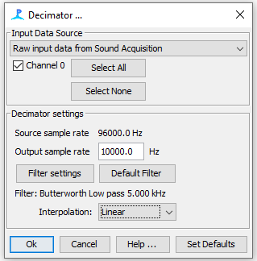

*Figure 18. The decimator allows users to down sample data.*

Next click Filter Settings.

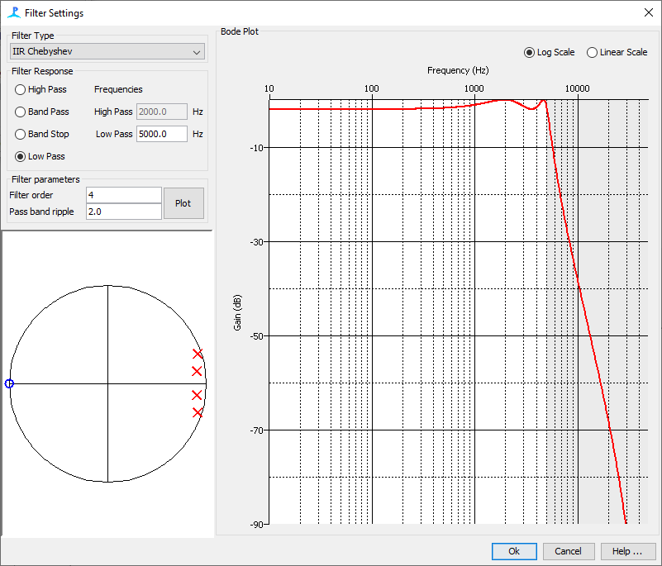

*Figure 19. The decimator module filter settings. It is very important to filter data before down-sampling to prevent aliasing.*

This brings up the standard PAMGuard filter settings dialog. The default settings are fine however ***Low Pass*** should be changed to 5000. Click OK.

Next add a new FFT module as before. It is a good to name this something obvious like “FFT Low Freq”

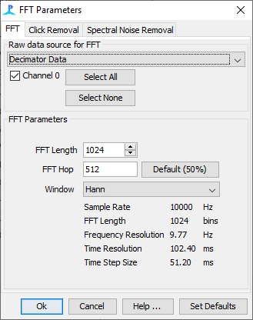

*Figure 20. The decimator has a different sample rate so will require another FFT (Spectrogram) module.*

Change default ***FFT length*** to 512 and the ***FFT Hop*** to 256. This helps low frequency spectrograms with time resolution. The data source, instead of the of being the Raw Sound Acquisition should be the Decimator data. Next add a new ***Whistle and Moan Detector***. Again, name this appropriately e.g. “Whistle and Moan Detector Low Freq”.

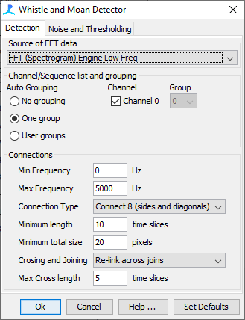

*Figure 21. The FFT (Spectrogram) settings for the down-sampled data. This will detect longer – lower frequency moans.*

The ***Max Frequency*** should be 5000, and the source should be your LF FFT, however the all the remaining settings can be as before.

Select ***File -> Show Data Model*** to open the data model. It’s a little bit more complicated now! We could keep adding to this model, adding filters, new detectors, however for this exercise we will stick with it as is.

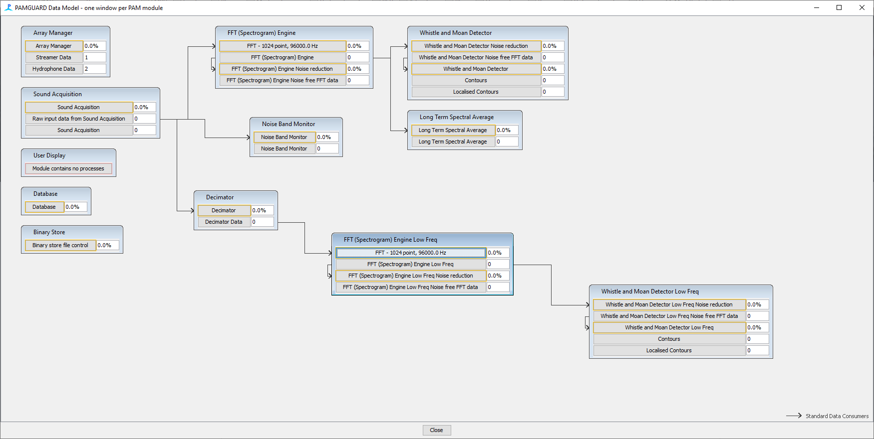*Figure 22. The data model is now beginning to look a bit more complex!*

Finally, we will wish to visualise the low frequency data. Add a spectrogram display exactly as before, except this time select the low Frequency data as a data source. Overlay the contours as before with the correct max frequency.

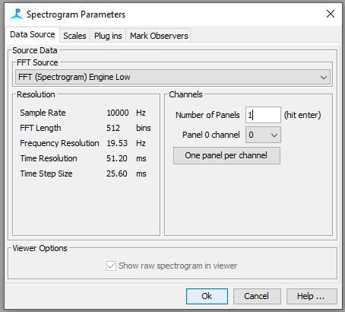

*Figure 23. Spectrogram settings for the low frequency spectrogram display.*

Finally, we need to add the click detector module to import clicks from the SoundTrap sud files. ***Go to File->Add Modules->Detectors->SoundTrap Click Detector.*** A click detector display will appear which will show the clicks when processing.

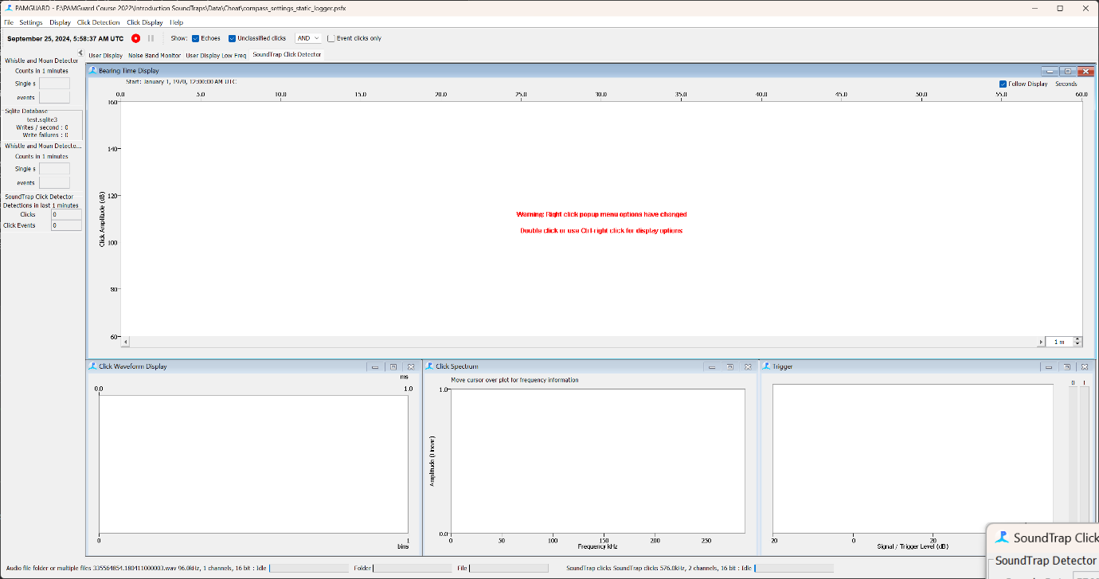

*Figure 24. The SoundTrap click detector display is exactly the same as the click detector display in PAMGuard.*

To check the everything is working go to ***Settings->SoundTrap Click detector->Sound Trap Settings.*** This will open the SoundTrap click detector dialog which will show the settings used by the SoundTrap to detect clicks.- note you cannot change these because the click have already been detected on-device.

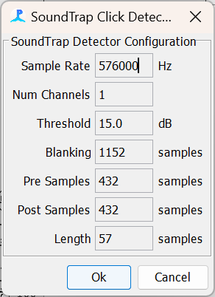

*Figure 25. The SoundTrap click detector settings. Here the SoundTrap has been recording at 576kHz sample rate with a threshold of 15dB to detect clicks.*

We are now ready to process the data but before you do SAVE YOUR CONFIGURATION!

## A side note on full bandwidth files

*In this example we have not added the usual Click Detector module as the SoundTrap has already detected clicks on-device during data collection. It is possible that a SoundTrap could be recording full bandwidth files instead of running a click detector. In this case the PAMGuard setup would be broadly similar with a few changes. Firstly, a normal click detector would be added.* ***File -> Add Modules -> Detectors -> Click Detector*** instead of the SoundTrap click detector***.*** *In the click detector settings* ***Settings-> Click Detector -> Detection Settings,*** *check that the correct channels are selected and set an appropriate threshold. 10dB is usually fine but in areas with a lot of ambient noise, such as coral reefs a slightly higher threshold is often a good idea*

*The Whistle and Moan Detector does not work particularly well on high frequency spectrograms. Above 30kHz, which is ~10~% of the frequency range of a full bandwidth spectrogram, there are no interesting tonal biological sounds. The whistle detector is therefore working on only 10% of the frequency range which, unless you set a very large FFT window, is lower in resolution than on a lower sample rate spectrogram. Add to that the fact that high frequency spectrograms are processor-intensive to run and it makes little sense to use the full sample rate data in analysis. It’s therefore a good idea to add a decimator to data to down sample to 48kHz Nyquist before the FFT module, which makes the analysis identical to this exercise.*

*Finally, It should be noted that click detection algorithms on SoundTrap and in PAMGuard are slightly different. This means that the results from running PAMGuard on recorded high frequency sound files will not be the same as recording lower frequency sound data on the SoundTrap and running a real time click detector. The exact algorithm used on the SoundTrap will be added to the PAMGuard click detector soon.*

# Processing the data

Time to start processing. Depending on the amount of data you have this can take anything between a few minutes to a few days. Generally, PAMGuard runs much faster than real time and it’s one of the fastest analysis programs around. As it churns through the data you will notice the binary folder filling up with files and the database getting larger. The first part of the exercise is now done! Congrats!

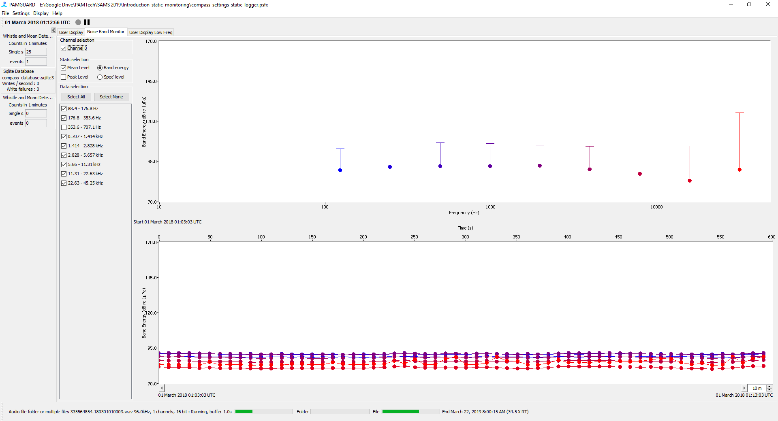

*Figure 26. The noise band monitor as PAMGuard processes data. The top display shows the current octave/third octave measurements. The lower display shows a time series of the different third octave measurements.*

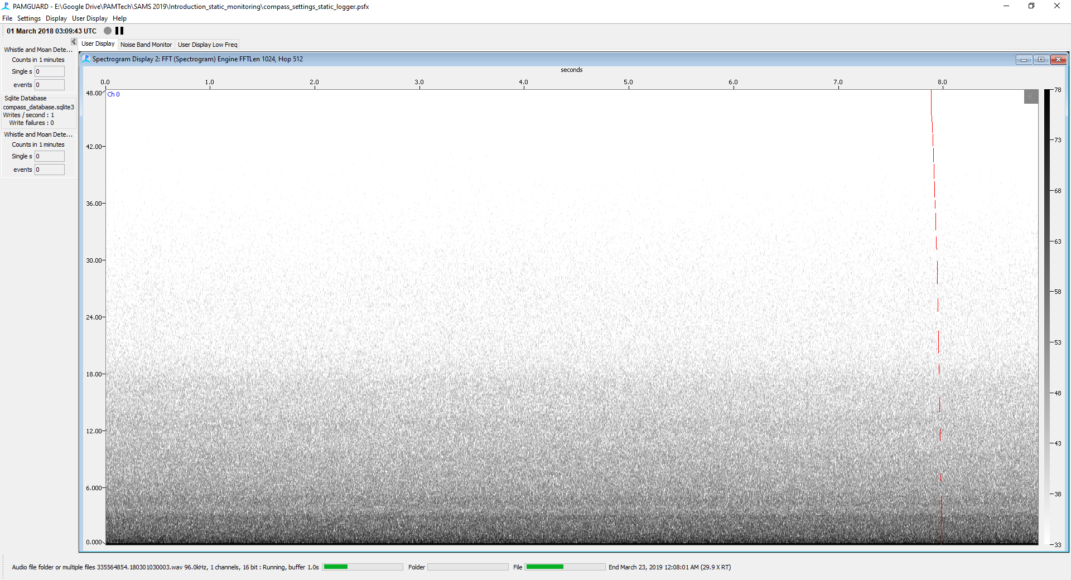

*Figure 27. The spectrogram display as PAMGuard processes data.*

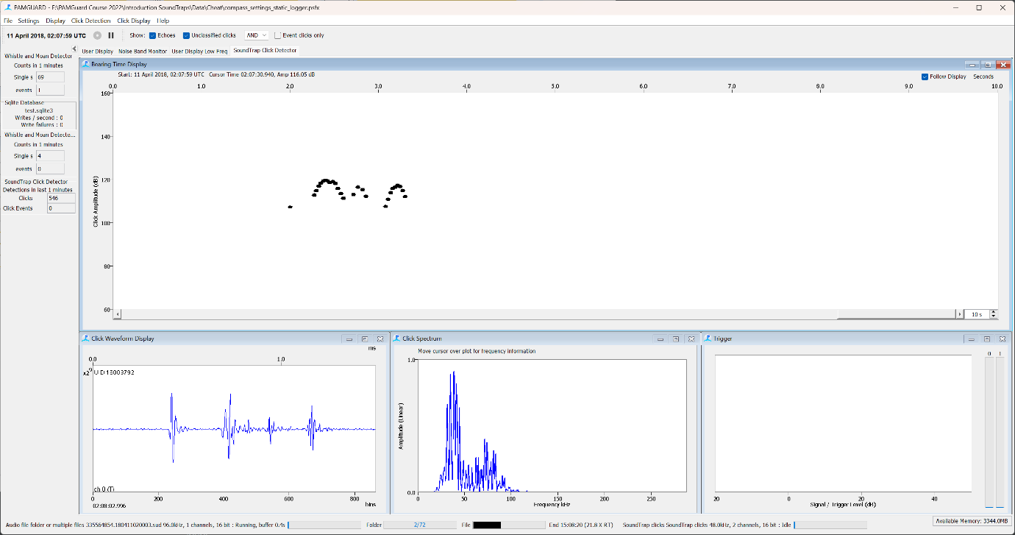

*Figure 28. As the PAMGuard processes, clicks will appear on the SoundTrap click display*

# PAMGuard viewer mode

## Navigating the dataset

Once PAMGuard has finished processing, the processed data can be viewed and further analysed in PAMGuard Viewer Mode. The full dataset (an example of which we used above) took a few days to process so we have the “cheat” binary files in a folder *viewer_mode.*

When you install PAMGuard, both Normal mode and Viewer mode are installed. So, to start PAMGuard Viewer, search for it in the Windows task bar or find it in program files. Once you open Viewer mode you will be prompted to select the database (for this exercise use *compass_database_start.sqlite3* from the Cheat folder), and then binary files in the *viewer* folder (this is just for training – normally you would use the database and binaries that you just created in Normal mode).

If opening for the first time or if more data have been added to either the database or the binary PAMGuard will want to create a datagram. This is an overview of all data collected which allows users to navigate to interesting section in the dataset. The Datagram Bin size is the time bin in which data are averaged. The default bin size of 600 seconds is fine in this instance. Lower bin sizes increase the resolution of the datagram, however, requires more memory.

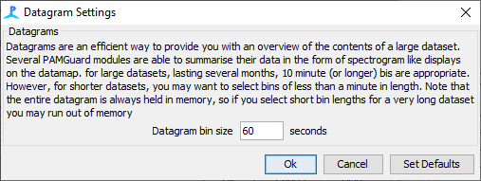

*Figure 29. The datagram bin size dialog. PAMGuard summarises different detections streams into a data map. The size of the summary time bins is the bin size.*

Click OK. If the datagram has not already been constructed PAMGuard will iterate through all the binary files creating a summary of each data type i.e. noise, LTSA, whistles etc. This can take some time.

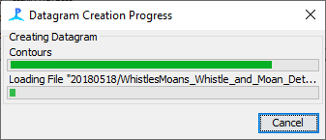

*Figure 30. The progress bar indicates the progress in generating a data map.*

Once processing is complete PAMGuard will have created a Data Map tab. This shows the datagram for each data stream. Here we can see (from top to bottom) the high frequency whistles and moans, the LTSA, the noise band monitor and the low frequency whistles. Each datagram is showing a time versus frequency display. Colours indicate the amount of data within each time/frequency, with white as nothing and then blue -> green -> yellow -> orange -> red showing more data. You can click on a datagram and use the mouse wheel to change the colour limits.

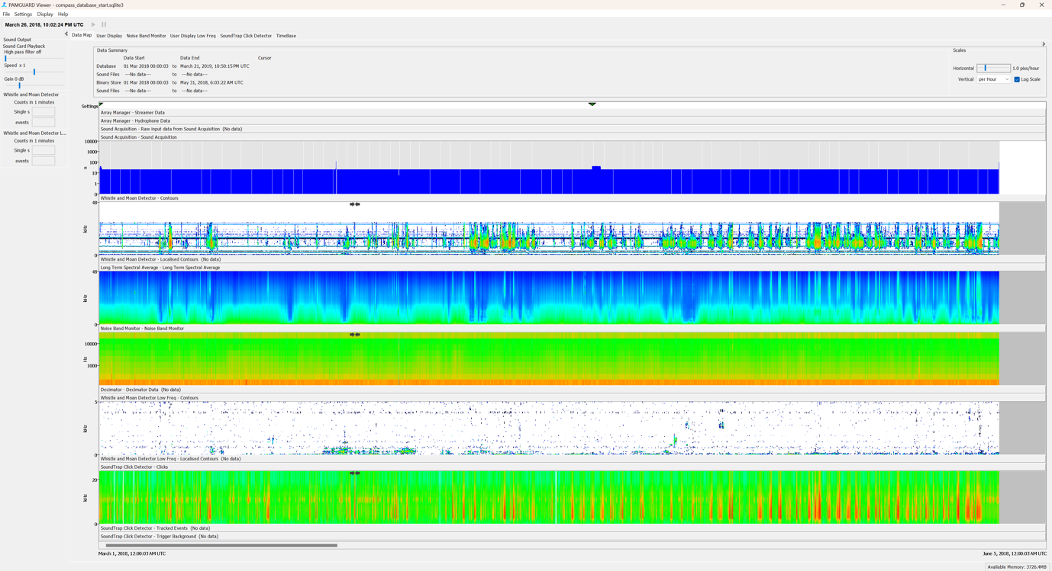

*Figure 31. The data map display in PAMGuard viewer mode. This shows a summary of the different data streams in PAMGuard over large temporal scales. Here it shows the data streams from modules added in the previous section i.e. the whistle and moan detector, an LTSA, noise measurements and the low frequency moan detector.*

The Data Map also allows users to change the time scale. Move the slider in the ***Scales*** pane to increase or decrease the time scale. If you decrease, you will notice the display fragments. This is because the SoundTrap was recording on a duty cycle. Grey areas indicate where there is no acoustic data.

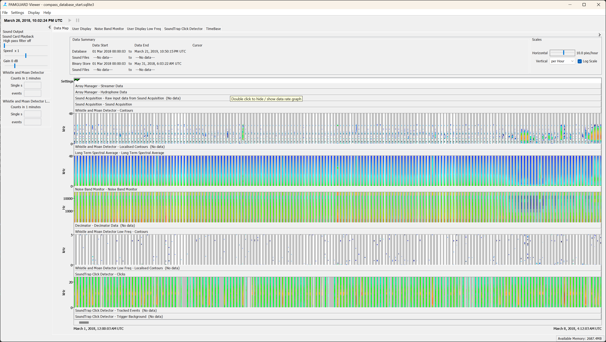

*Figure 32. When the data map time scale is zoomed in you can see the duty cycle of the SoundTrap.*

Sliding the time scale back to see most of the dataset it should be fairly obvious that in this example there are many time periods where there are lots of high frequency whistles. Right click on such a section and click ***Centre Data Here*.** PAMGuard will then load up a section of data so it can be viewed on a display. Click the ***High Freq Spectrogram*** display. You should notice that it is full of detected whistle contours. These are clearly dolphins.

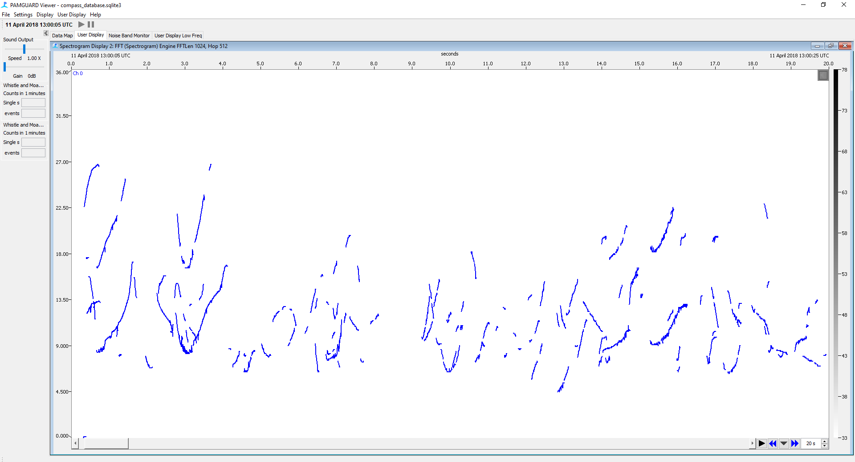

*Figure 33. The spectrogram shows the whistle and moan detections.*

You can set how much data PAMGuard loads up in a period by clicking the down arrow in the bottom right of the spectrogram display. This will bring up a small dialog box. Make the **Duration** 10 minutes. PAMGuard will then load up 10 minute chunks of data each time you move to a new section of the dataset. The reason for this is that as the datasets are so large, PAMGuard cannot load all detection into memory. Keeping time chunks relatively short reduces load times and memory requirements, making PAMGuard faster and more stable. Once you want to move on to another section you can either go back to the Data Map and right click **Centre Data Here,** click the down arrow and manually enter a **Start Time** or click the double arrows forward or back. The spinner allows you to change how much data is shown on the display (as opposed to loaded into memory)

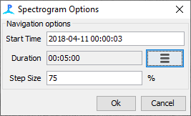

Figure 34. This generic navigation dialog is used in almost all display in viewer model to allow users to navigate to new sections of data.

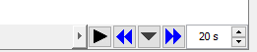

Spinner to change time period of data shown in display

Double arrows load up the preceding or next 10-minute section of data into memory.

Plays through the data as if it were being collected in real time

Open a dialog to set how much data is loaded into memory. Also allows a user to jump to a specific time period.

One of the most important aspects of PAM analysis is calculating how well detectors work. For this we need to view raw data. To allow Viewer mode to load raw data into displays, i.e. raw spectrograms, click **Settings-> Sound Acquisition.** This will bring up the Sound Acquisition settings. Select ***Use offline files*** then click ***Browse*** and direct PAMGuard to the folder containing the raw audio data (Data/wav).

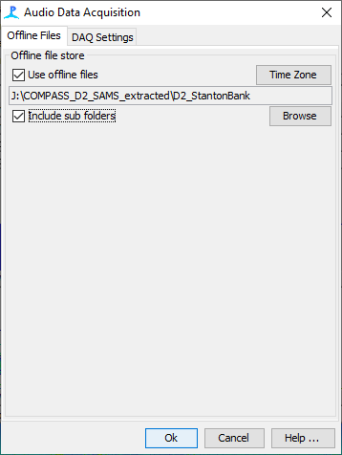

*Figure 35. Load raw data files to show raw data in PAMGuard displays.*

PAMGuard will then load up the raw audio files and present them as another datastream in the DataM ap. You can load up the entire set of raw files or just a sub section. For example raw files may be spread out on multiple hard drives.

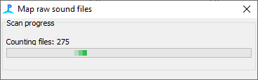

Figure 36. Progress dialog for mapping raw data files.

Once raw data are loaded, if a section of data has a corresponding raw audio file, PAMGuard will automatically load the raw audio data and show the spectrogram as well as the detection data. Here you can see that the Whistle and Moan detector has picked out most of the contours but not all.

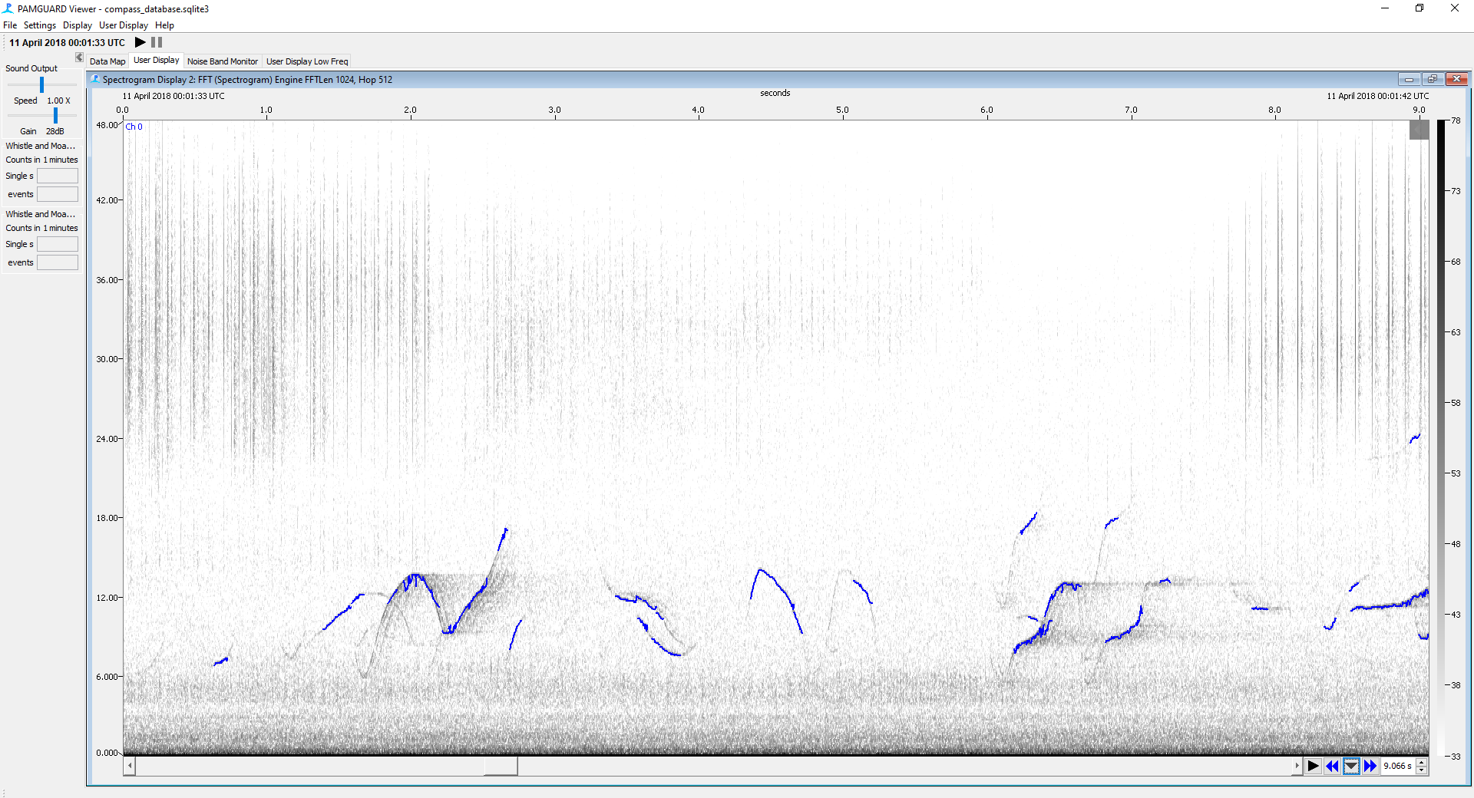

*Figure 37. Once raw data has been imported it will be shown in the spectrogram display.*

Perhaps in subsequent analysis runs, lowering the threshold on the Whistle and Moan detector would pick up more contours. It may however also pick up many more false positives. Detectors are always a trade-off between picking up the signal of interest and not picking up spurious detections i.e. false positives.

The key to manually investigating large datasets like these is trying to look for sections in the data map that are different. Clearly high frequency whistles are very obvious and in this dataset there are a lot of them! However, take a look at the low frequency whistle and moan detector (bottom datagram). This is a lot more sparse. However, there are low frequency sections that seem to contain a little activity.

Right click on one of these sections (e.g. 25th March 2018 18:00) and go the Low Frequency Spectrogram. You will see there are a bunch of low frequency tonal sounds. Right click *and* ***select Play Channel 0 from Start*.** If the volume is too low increase the Gain in left hand panel. These are humpback whales!

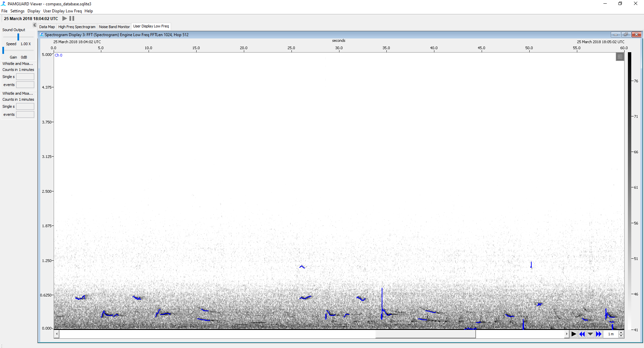

*Figure 38. Low frequency moans displayed on the spectrogram display.*

Take another look at the low frequency spectrogram. Note a strange section of high frequency tonal sounds (e.g. 28th April 2018 07:15). Right click ***Center data here*** on this section and go back to the Low Frequency Spectrogram.

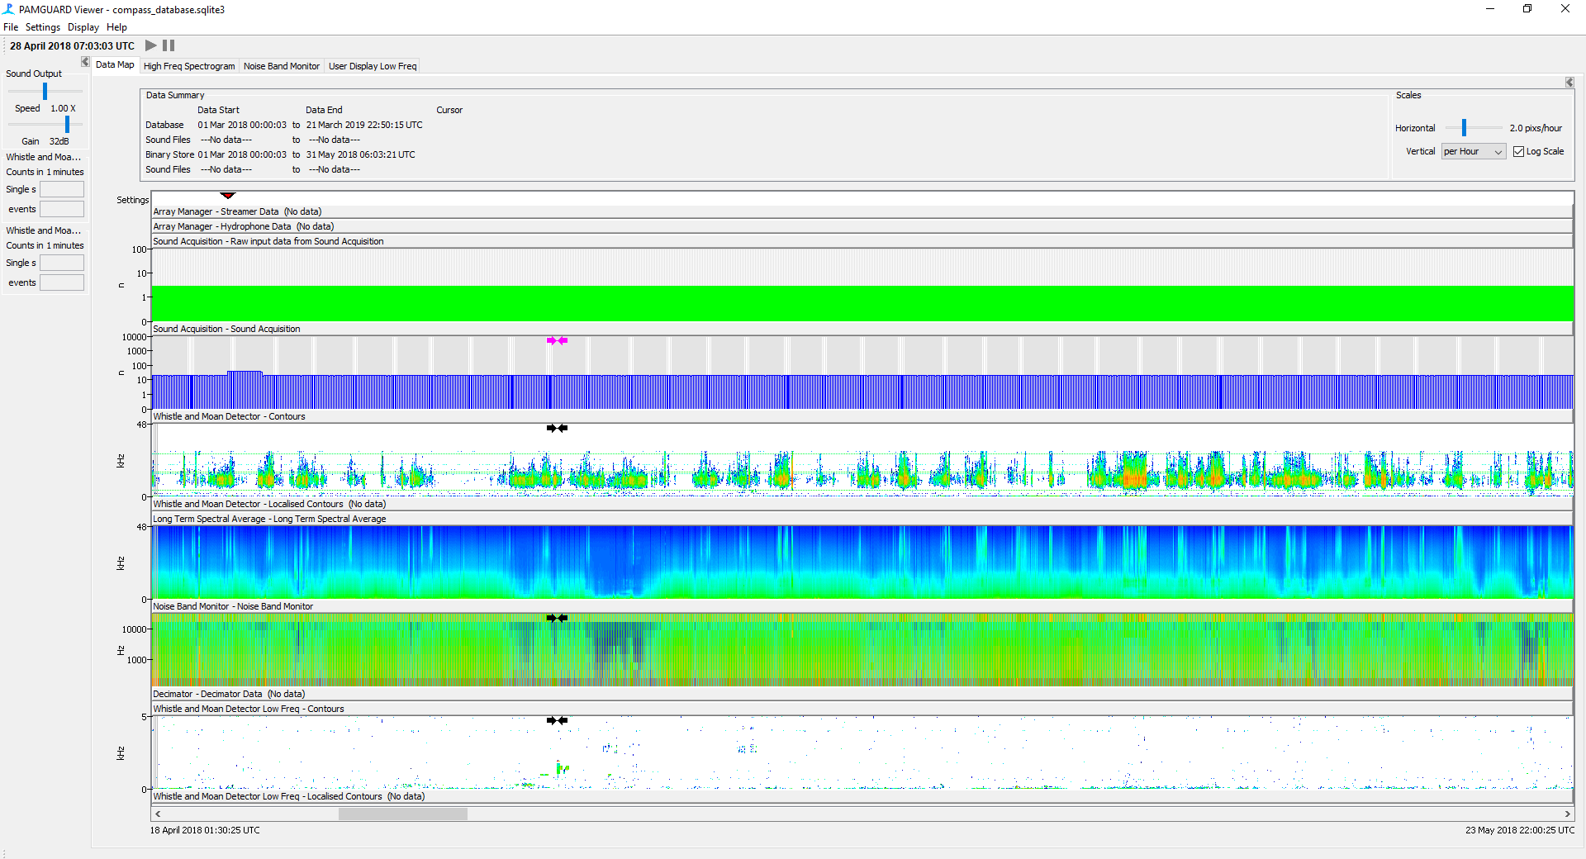

*Figure 39. Use the datagram to find unusual patterns in the low frequency data display.*

This is likely military sonar.

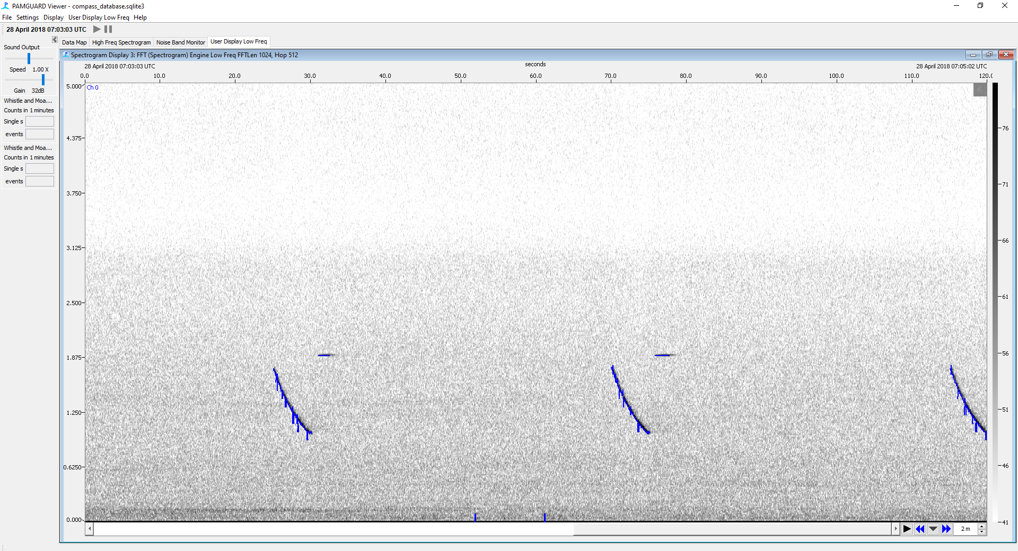

*Figure 40. Military sonar.*

Have a closer look at the ***Data Map*** and you will begin to see interesting sections, including ship noise and more sonar.

The datagram works exactly the same as before. Find an interesting section, right click a select ***Centre Data Here*.** Next switch to the SoundTrap Click Detector display. Right click and select Amplitude/Time to show the amplitude axis. Click on clicks to see waveform, spectrum and Wigner plots. The example below is a porpoise click. You can clearly see the click trains.

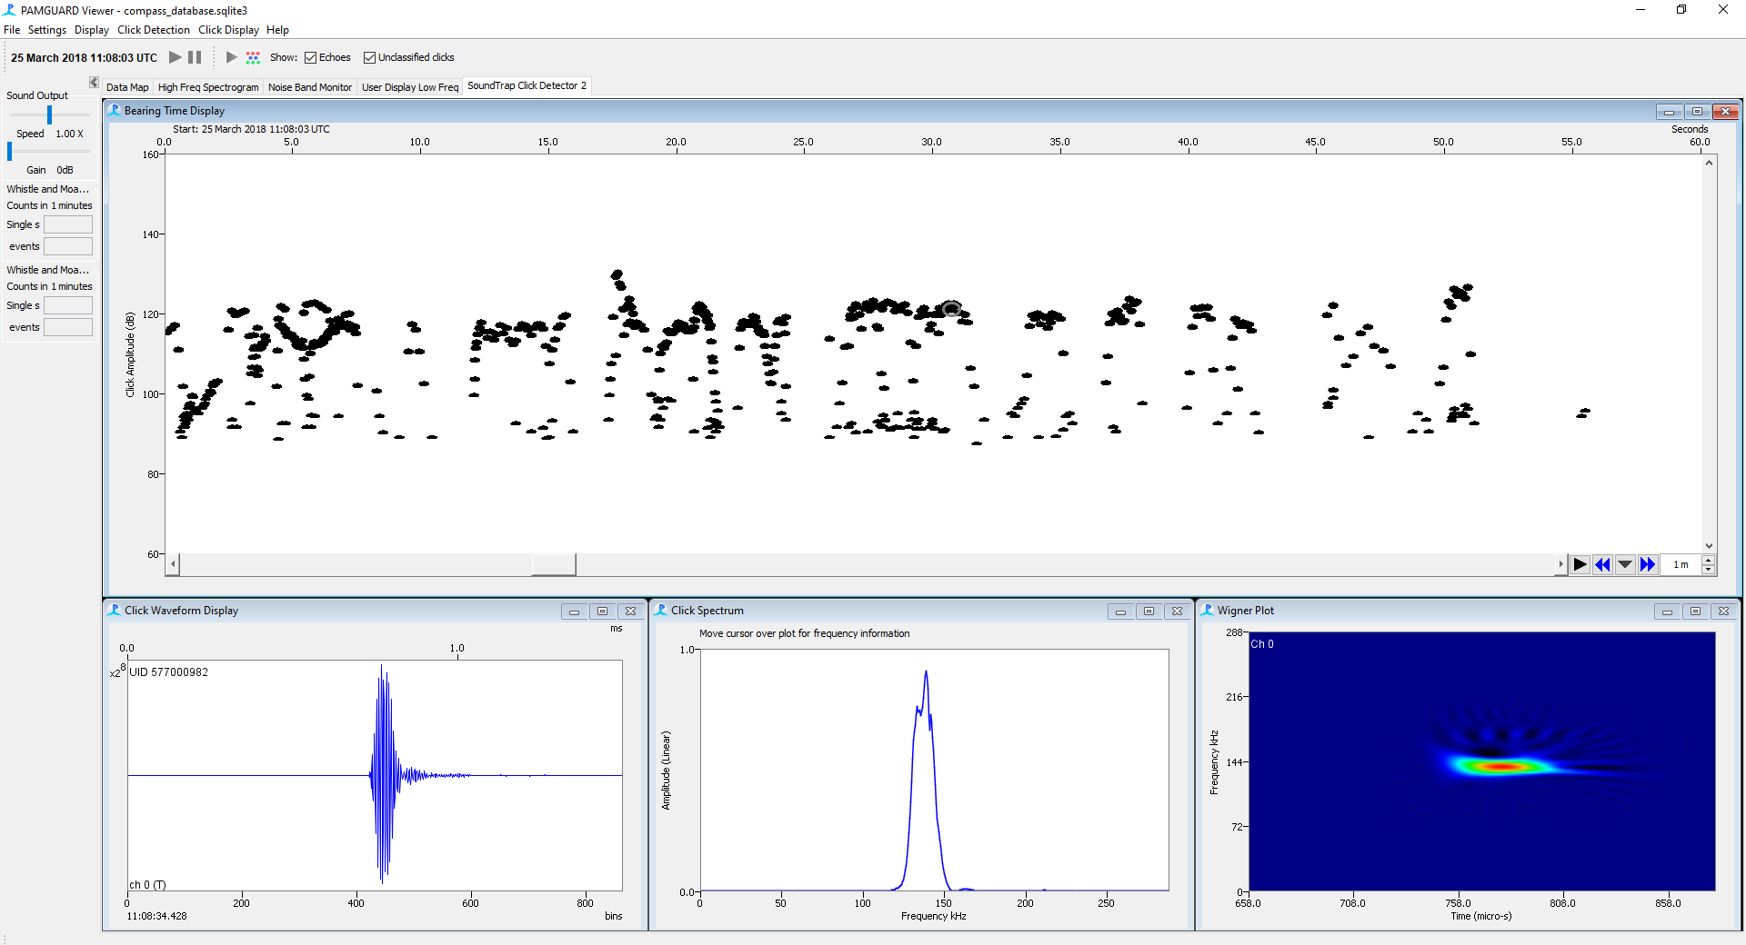

*Figure 41. Click detections shown in the click display.*

Check out the dolphin clicks. They are more broadband and clearly visible on the click datagram.

## The time base display

The click detector and spectrogram were amongst the first displays programmed in PAMGuard, over a decade ago. Although both displays are powerful ways to visualise data they do have some disadvantages. One is that they can only display their own respective time series, so the Click Detector can only display clicks, and the spectrogram can only show frequency time-based data. The newer “Time base” allows users to visualise different data types together. We will create a display to show whistle detections and clicks. First add another display tab. ***File -> Add Modules -> Displays -> User Display*,** and name it something sensible**.** Next, click on the new User Display tab and click on the top bar ***User Display*** (or whatever you named the new user display) ***-> New Time Base display fx.*** You will now see a new display. Expand the top bar by clicking the down arrow at the top of the display. The time display allows you to add most data types. To add a data type click the ***+ Add*** button in the Display Data panel***-> SoundTrap Click Detector, Clicks***

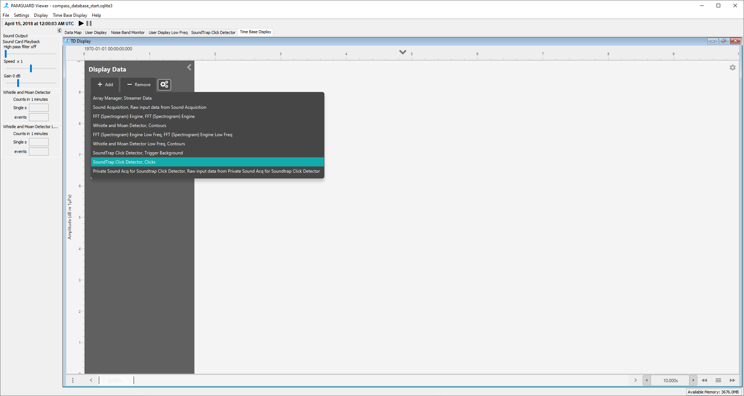

*Figure 42. After the time base display has first been added to PAMGuard, it is a blank canvas. The display can show multiple data streams.*

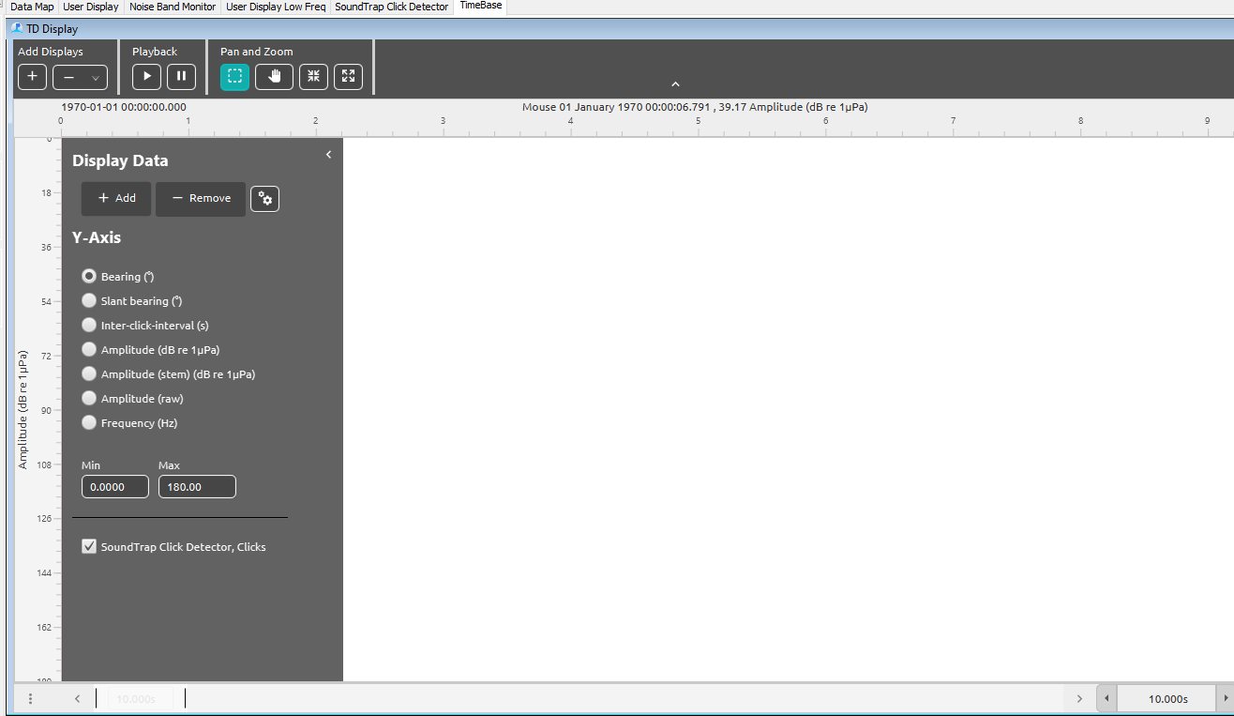

*Figure 43. Once a data has been added the types of y-axis that can be used to the display are added to the settings panel.*

Once you add the clicks change the display load time in the bottom right hand corner from 0 to 10 minutes using the hamburger icon. You should now see clicks on the display, a bit like the click detector.

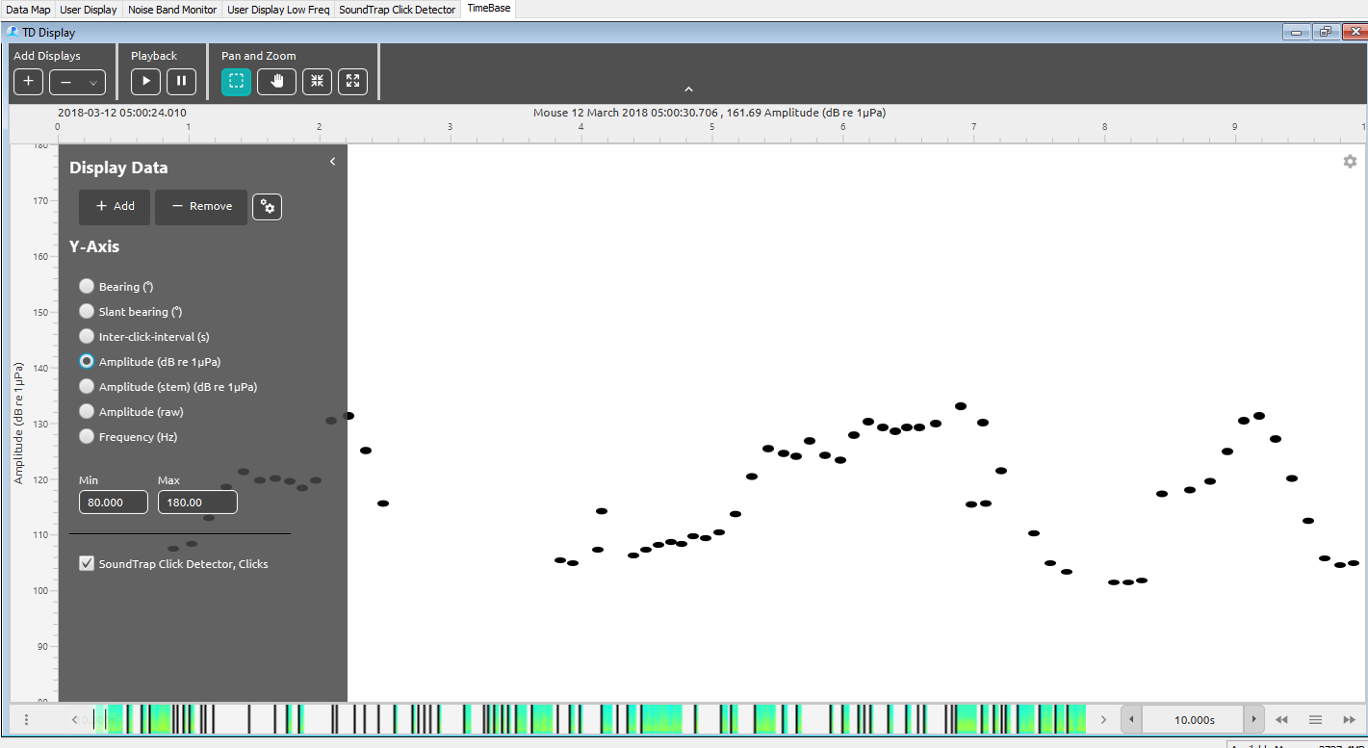

*Figure 44. Click detections displayed on the time-base display.*

The time scales are changed by dragging the edges of the scroll bar. Also note that a small click datagram is present in the scroll bar. You can use the left menu to change what axis to show the clicks on and what the limits of the axis are. For example, select ***Frequency (Hz)*** to show the FFT spectra of clicks

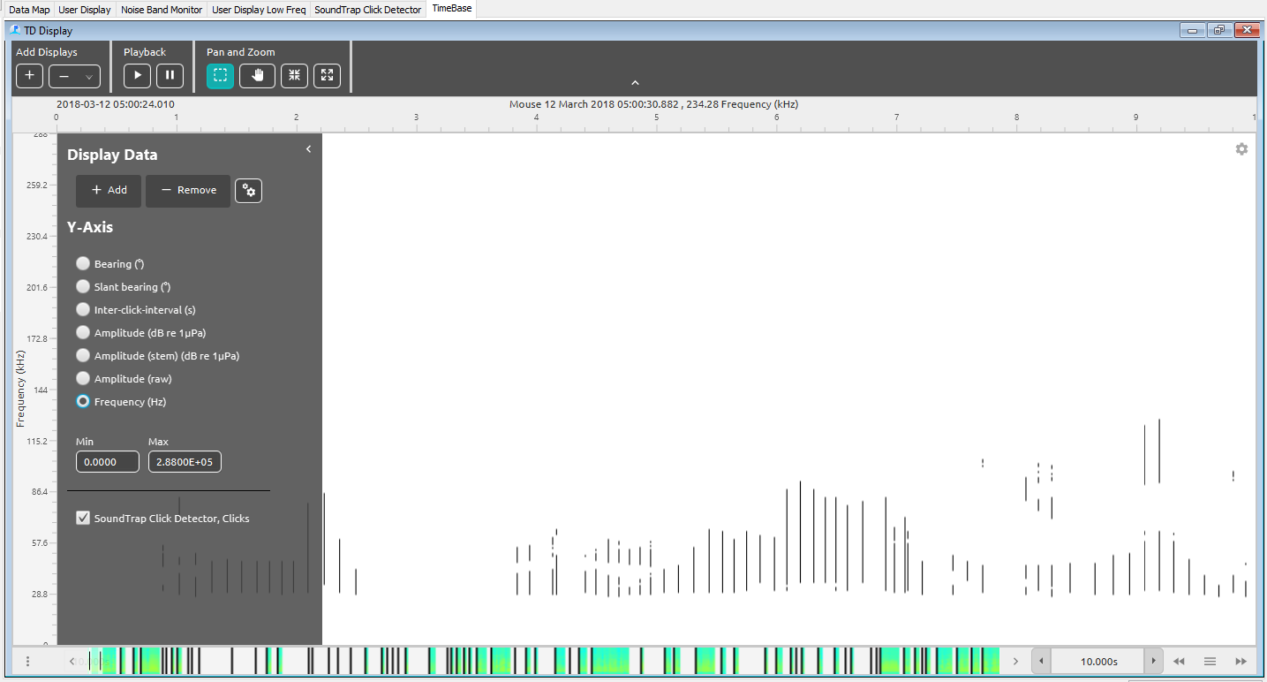

*Figure 45. Frequency spectra of clicks displayed on the time-base display.*

Use the right menu to select how the clicks are visualised, for example what colour they are, which types of click are displayed (comes in useful later when we run automated algorithms). You can expand the symbol options for each display type, and check the boxes (Symbol, Border, Fill), deselect the display type using the blue slider to the left of the pane, and change the order of preference for display by moving the options up and down with the **–** draghandle to the right.

Enable and expand **Peak frequency** and in the colour gradient menu select a multi coloured array. Check border and fill. Next click on the cogs button in the left hand **Display Data** section and change the display background. Finally click **Amplitude (stem)** in the graph axis pane. You now have a display which looks a bit like CPOD.exe.

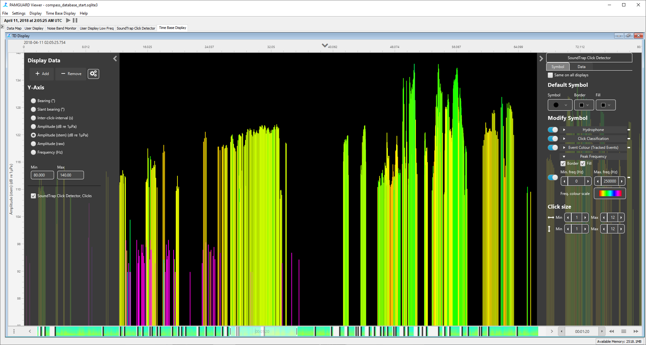

*Figure 46 Clicks displayed as a stem plot coloured by peak frequency (similar to CPOD.exe)*

Switch back to a ***Frequency (Hz)*** and the narrow band clicks of a porpoise are even more obvious.

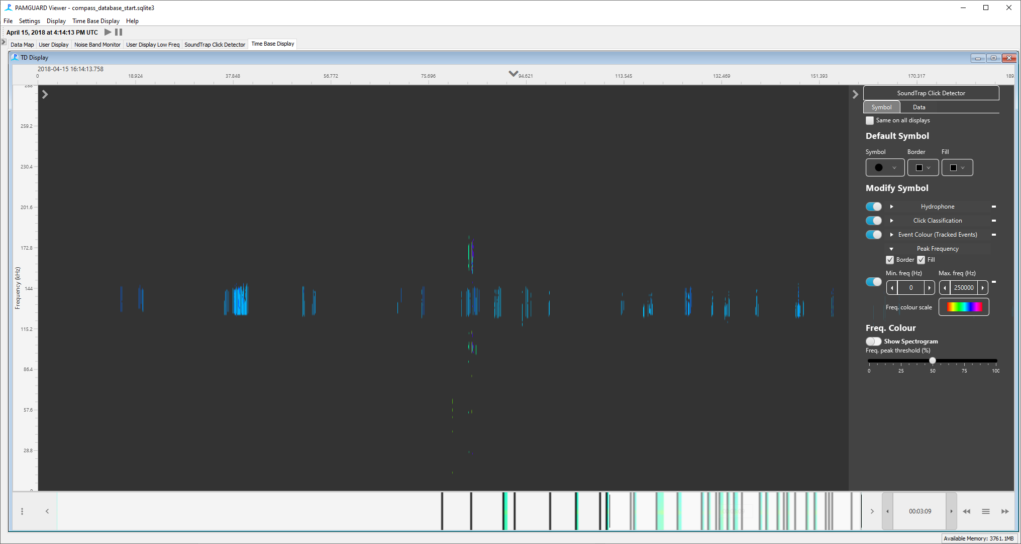

*Figure 47. Porpoise click spectra shown coloured by peak frequency and plotted in the time-base display.*

Compare these to a section of the data with dolphin clicks…

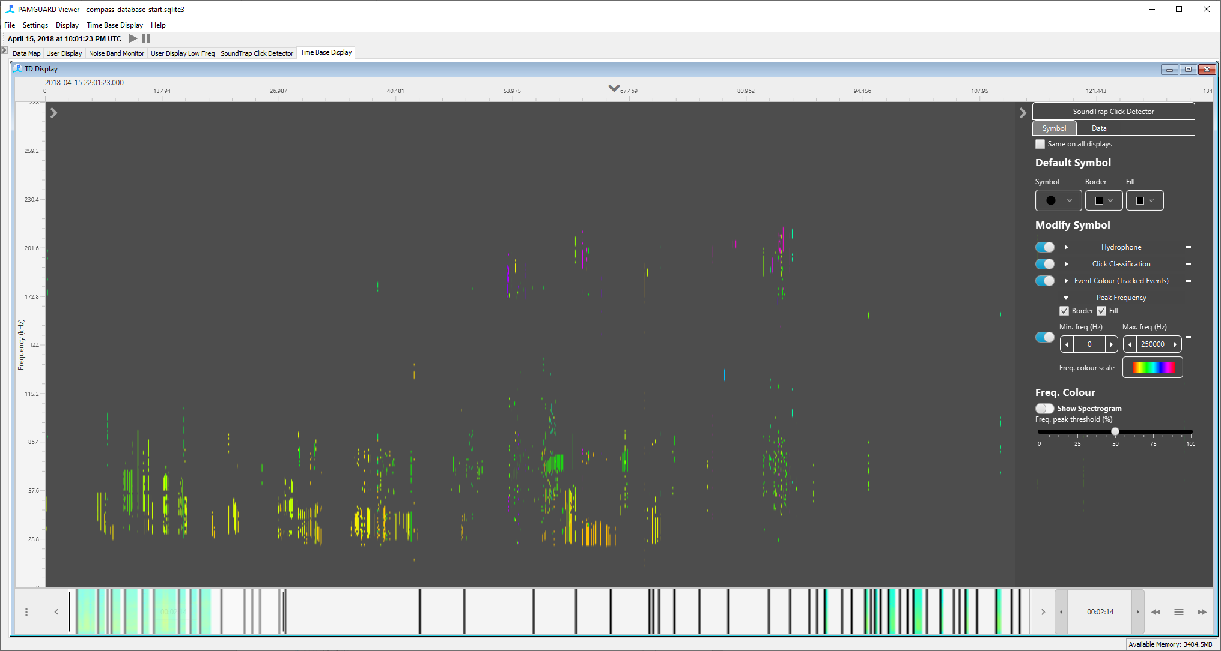

*Figure 48. Dolphin clicks plotted on a frequency axis in the time-base display.*

If you select Frequency for the y axis (in the left pane), at the bottom of the right pane you’ll see the option to Show Spectrogram and see the full FFT on the display. Have a go at using that to visualise the spectra of individual clicks.

Experiment with the many different display options available in the left and right panes, and use them to compare dolphin and porpoise clicks.

The time display also interacts with individual data units. Again, select amplitude (dB…) for the y axis, then click on the cogs next to the Add/Remove buttons. In ***Pop up Menu Type***select ***Adv. Pop up Menu*.**

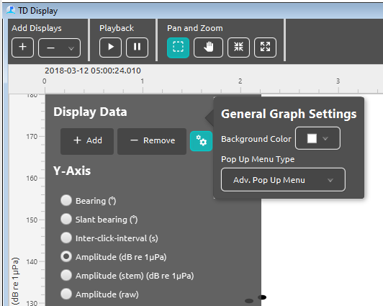

*Figure 49. Users must select the* ***Advanced Pop Up Menu*** *in the general graph settings (this will become default soon).*

Drag a box over some clicks and right click**.**

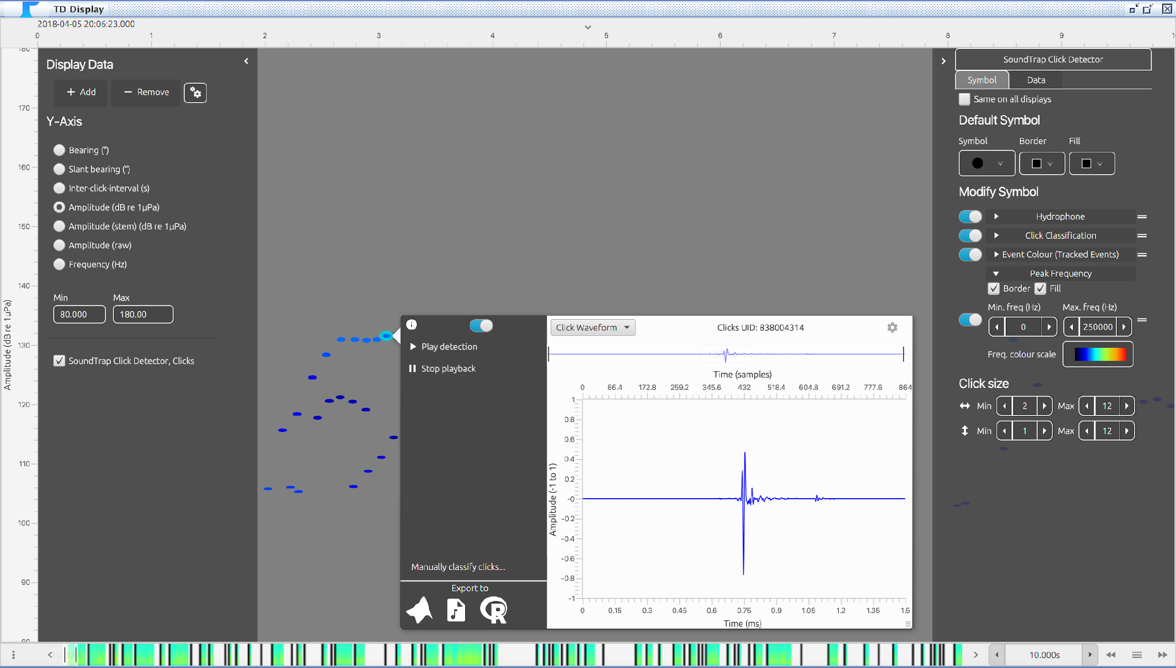

Figure 50. Clicks plotted as amplitude (dB) and coloured by peak frequency. The adv. Pop up menu shows a preview the click detection.

Use the arrow keys on the top right to iterate through the clicks selected in the box, the blue slider line to move through time and the click waveform button to choose how to display each click.

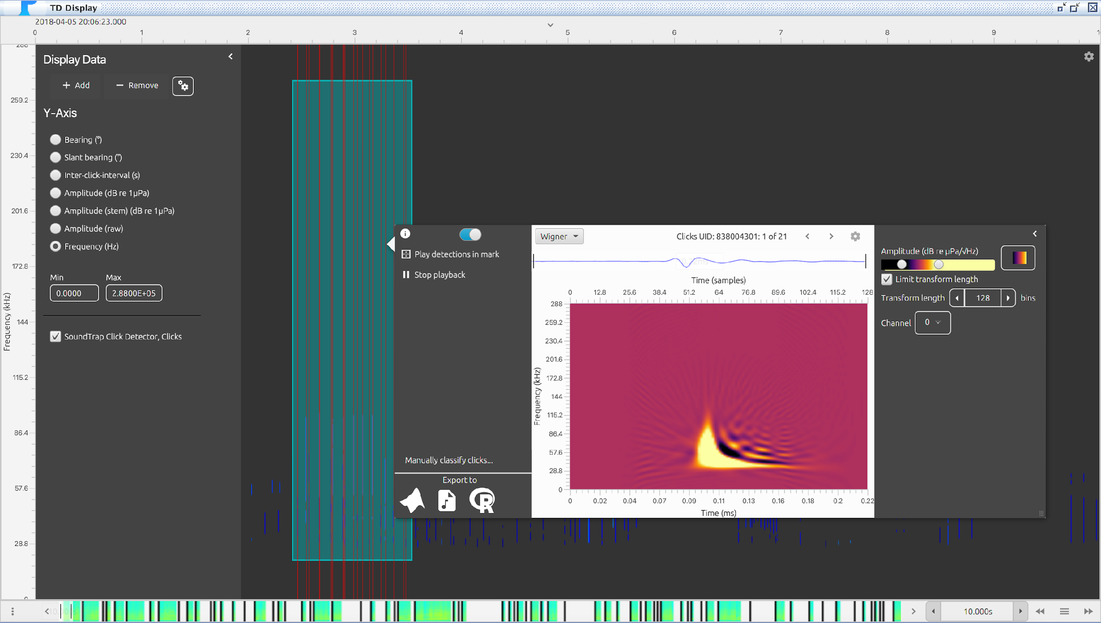

Figure 51. The adv. Pop up menu can also show a Wigner plot of a click.

There is also the option to export these clicks to R, MATLAB etc.

If you select Amplitude (raw) for the y-axis, you can then right click on individual clicks, and use the Pan and Zoom tools in the top pane to investigate the waveform detail of each click.

Clicks are not the only data units that can be displayed on the Time Display. Click ***+Add*** and add ***Whistle and Moan Detector,*** ***Contours***. Go to a section of data with some whistles

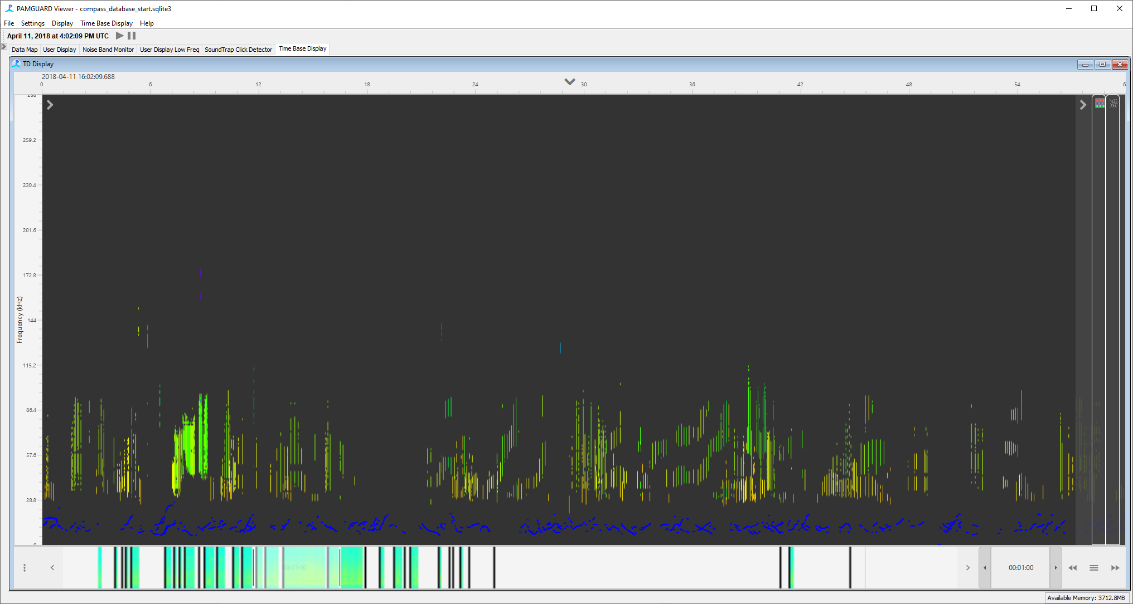

*Figure 52. Whistle contours and clicks plotted on a frequency axis. The large frequency range of clicks (0-238kHz) compared to whistles (0-48kHz) means that plotting these two data streams on the same display is not particularly useful.*

This is not particularly useful because contours are such low frequency compared to clicks. Instead let’s add another graph which can have different frequency limits. Select the **+** button on the *top* left of the display. This will add a new graph. Click ***+ Add*** in the new plotand add ***Contours***

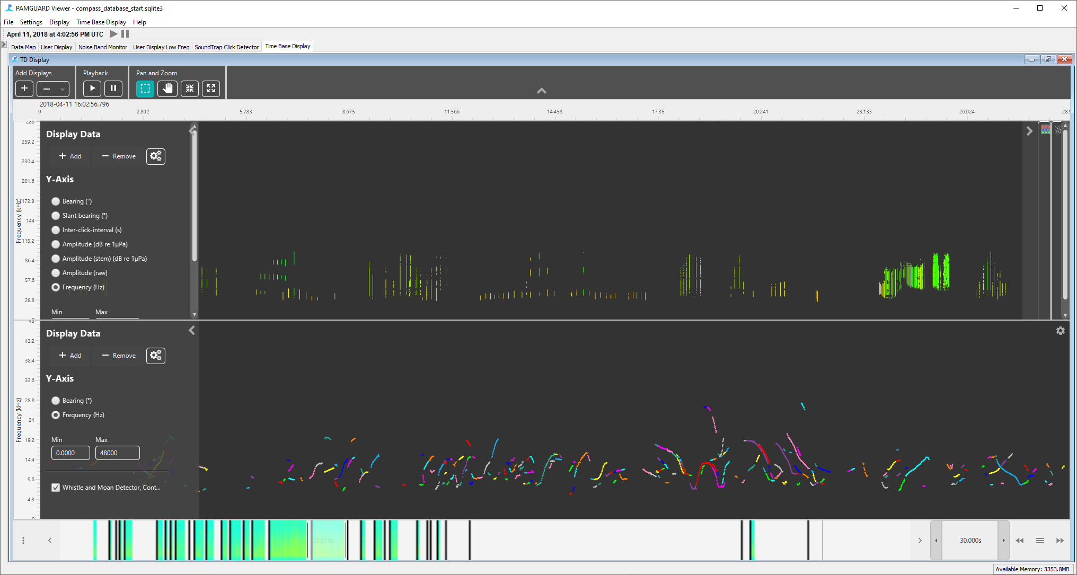

*Figure 53. Whistle detections can be displayed on a second plot.*

You can now view the click and whistle data together. If you add the ***FFT (Spectrogram) Engine*** to the lower plot, then you will be able to see the raw spectrogram data overlaid with whistle detector data.

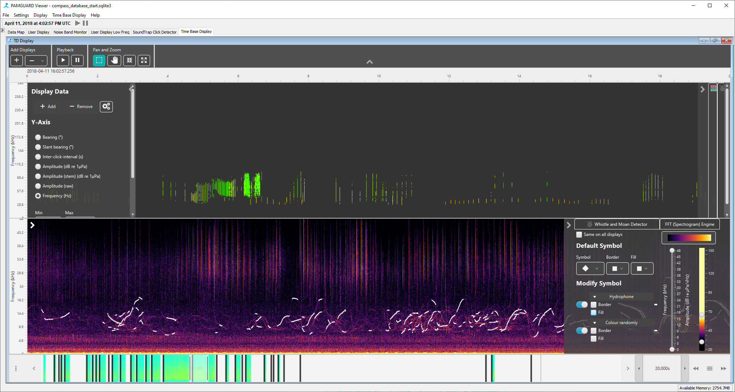

*Figure 54 Adding FFT (Spectrogram) Engine will to the lower plot results in the raw sound data being plotted behind the whistle detection contours.*

Explore different ways of visualising the data. Go to different sections in the data map and see what you can find.

## Automatic classification

The SoundTrap is running a very simple energy detector which will detect any transient sounds (e.g. shrimp, boats, knocking as well as echolocation clicks). Usually, we need to classify these sounds to species for any further downstream analysis. PAMGuard has a multitude of approaches for this including click train detectors, AI methods, match click classifiers and others. Here we are going to run the simple click classifier built into the Click Detector Module to look for harbour porpoises. First, we need to set up the click classifier. Go to **Settings-> SoundTrap Click Detector-> Click classification….** This will bring up the click classification table. Click ***New*** to add a new classifier. On the bottom right of the classification settings pane that pops up, select ***Default->Porpoise***. The default settings are not great here, disable ***Zero crossings*** and change the ***Length*** range to between 0.03 and 0.2. Click ***Ok***.

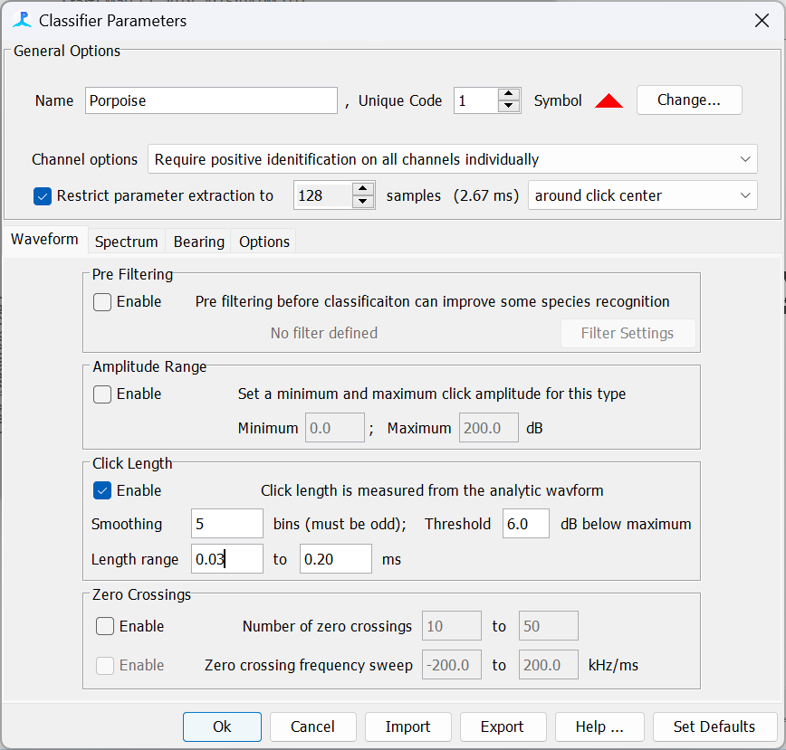

*Figure 55. Click classifier settings for detecting porpoise clicks. First select Set Defaults->Porpoise. Altering the length and disabling zero crossings often improves classification.*

We have a huge dataset (well medium sized by PAMGuard standards), so we need to tell PAMGuard to process through all the clicks using the new click classifier. Anytime we change settings we have to repeat this process. To process the data, go to ***Settings->SoundTrap Click detector -> Reanalyse licks…*** (you can also access this menu by clicking the multi-coloured icon at the top of the Click Display).In the top ***Data options*** menu select ***All Data*** to process the entire dataset. Tick ***Reclassify clicks*** and press ***Start***. PAMGuard will now run all clicks in the dataset through the click classifier (this can take a few minutes).

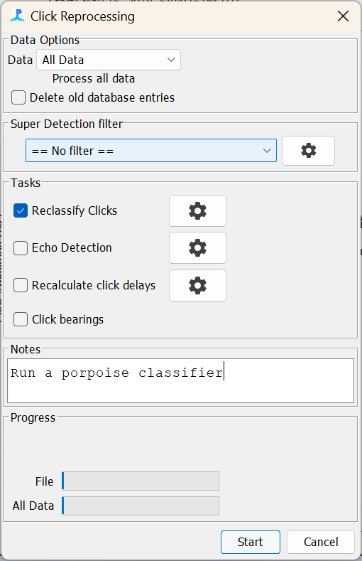

*Figure 56. Once the classifier has been set up the entire dataset can be processed using the Click Reprocessing dialog.*

There are going to be a lot of times that we don’t have porpoises around – to find our classified clicks we need to go to the Data Map. Right click on the ***SoundTrap Click Detector -clicks*** datagram and select show detections. You will now see red bars where porpoise clicks have been detected. Look through dataset for a red bar that is higher than usual and navigate to this section of data by right clicks and ***Centre data here***.

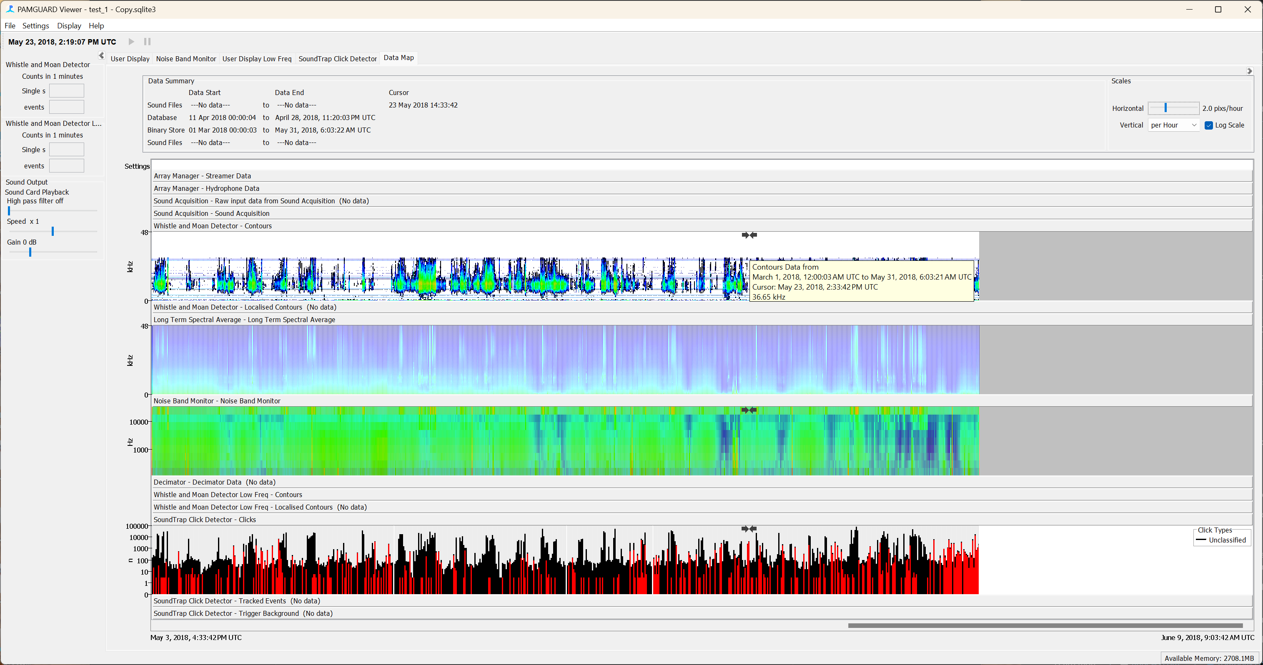

*Figure 57. After data have been reprocessed, the number of classified clicks is summarised in the data map. Red bars indicate the number of porpoise clicks classified in a time period.*

Go back to the click display and have a look to see if you can find the porpoise clicks. For example, you should see some nice porpoise clicks around May 7th 2018 10:00:00. To make it easier to visualise the data we need to tell the click display to show classified clicks as a different colour. Right click on the click display and select ***More symbol options***…. Make sure all ***Colour By click Classification*** boxes are ticked. Any porpoise clicks will now appear as red triangles.

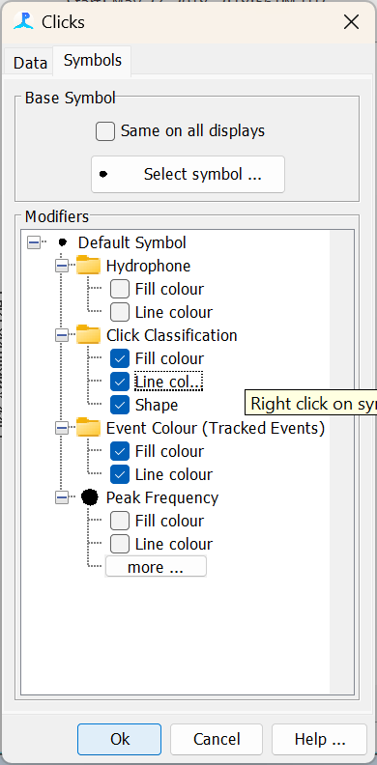

Figure 58. The symbol manager indicates how symbols are coloured across all displays in PAMGuard.

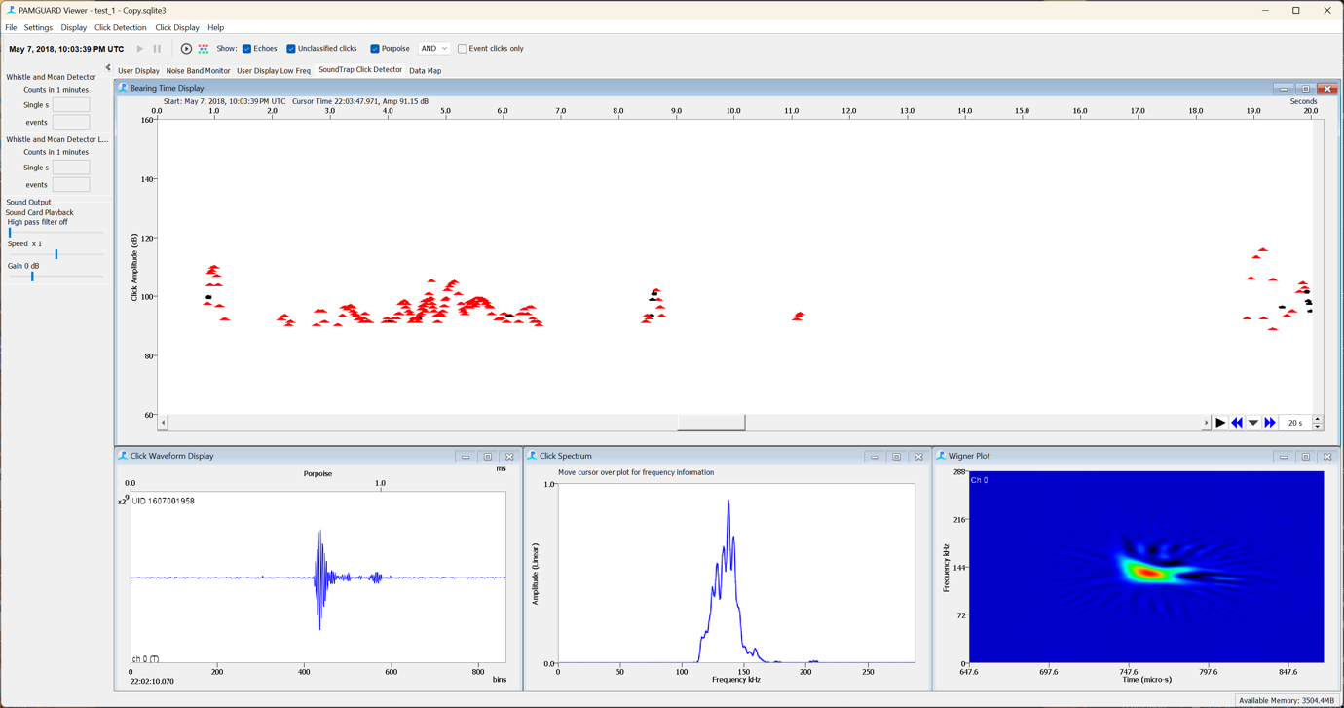*Figure 59. Detecetd clicks which have been classified as porpoise. Click on a click and the waveforms look like classic narrow band high frequency species.*

Now try find the same clicks in the time display – note that symbol options are in the right hand settings pane for clicks.

Note that this is a very simple classifier – there will still be false detections but it helps identify sections of the data where there might be porpoise clicks. For more accurate classification we would need to move to a click train or AI based approach (both of which are possible in PAMGuard) and/or export the porpoise clicks and run some further analysis on them.

## Exporting data

There are currently three ways in which data can be exporting in PAMGuard, programmatically through MATLAB (www.github.com/PAMGuard/PAMGuardMatlab), R (www.github.com/TaikiSan21/PamBinaries) (Python coming soon), to an external database such as Tethys or directly via the exporter.

Exporting using a programming language is very flexible but requires programming know-how and Tethys databases are a whole separate tutorial. The in-built exporter in PAMGuard is easy to use and allows users to export to various file formats and filter data by time or type without the need for any code. Users can then go on to process the data in whichever way they require.

To open to the exporter, go to ***File->Export Data…*** This opens the exporter dialog.

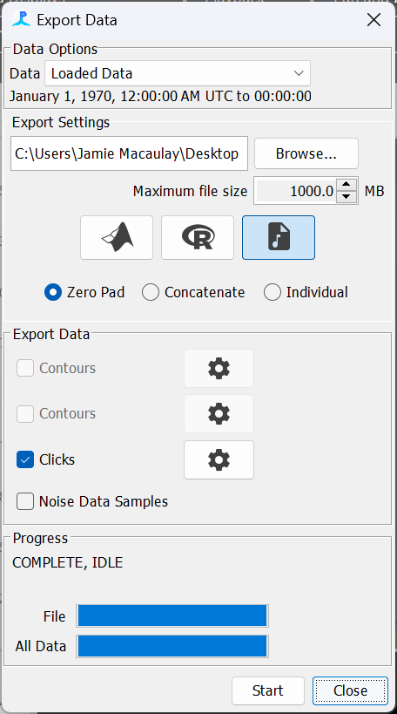

*Figure 60. PAMGuard has a powerful exporter which allows users to export data to different formats.*

The exporter currently allows users to select MATLAB, R or wav as the export file type. Not all detections can be exported as these files. For example, you will notice that when you select wav, exporting whistle contours is disabled. This is because whistle contours contain no raw waveform information and so cannot be exported to a wav file. Data exported to MATLAB and R are saved as structs allowing you to directly access metadata such as time, classification info, annotation etc for each detection. More information on the exporter is available by going to the help file.

Here we are going to export a set of clicks and save as a zero padded wav file. PAMGuard will save the clicks to a wav so that time is preserved – the space between the clicks is padded with zeros. Navigate to a section of data with lots of clicks e.g. 12th April 2018 16:10:00. Click ***Browse…*** to select a folder to save to, select the wav file symbol and make sure ***Zero Pad*** is selected. Click start and all loaded clicks will be exported to a wav file. Note that you can change which data are exported in the top ***Data Options*** menu. Clicking the cog icon next to each data type also allows users to filter data. For example, you can choose to export only classified and/or manually annotated clicks – here, this would allow us to export all classified porpoise clicks to MATLAB, R or even a wav file.

Locate the exported wav file and open it in your favourite wav viewing program e.g. Audacity, Sonic Visualiser (our favourite), Raven etc. You should clearly see the exported clicks in the file.

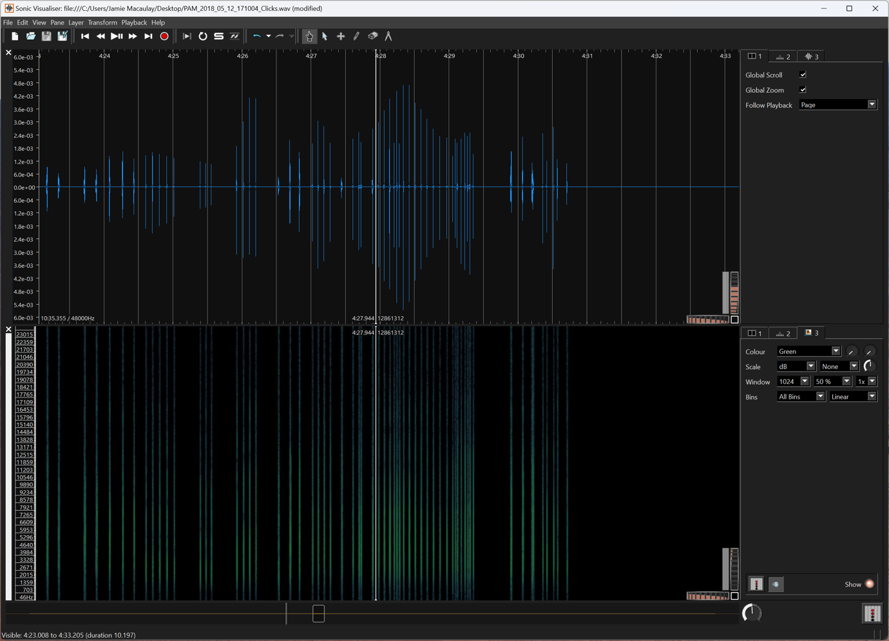

*Figure 61. An exported wav file of SoundTrap clicks detections opened in Sonic Visualiser (*[*https://www.sonicvisualiser.org/*](https://www.sonicvisualiser.org/)*).*

# Summary

Well done on completing the exercise – you have achieved the following:

* Set up PAMGuard to analyse sound files from a recorder, running tonal detectors and some basic soundscape metrics.
* Opened the dataset in PAMGuard viewer mode and explored the data.
* Used the Time Base Display to visualise data in different ways.
* Run a simple automated click classifier to find porpoise clicks.
* Exported data

This exercise has focused on using detection data to allow a user to explore a large dataset. However, although large numbers of detections are easy to find in the Data Map (i.e. the huge number of dolphin whistles) small numbers of clicks, perhaps from beaked whales are not going to be very obvious within these large data averages. Subsequent tutorials explain how to use more advanced species classifiers and AI in PAMGuard.

# Acknowledgements

We would like to thank Scottish Association for Marine Science for supplying the datasets. Data was from the COMPASS project (www.sams.ac.uk/science/projects/compass/) which was funded by the EU INTERREG VA Programme.

Thanks to Dr Denise Risch and SAMS for funding the initial development of materials. Further development of these materials was funded by the CIBBRiNA peoject (https://cibbrina.eu/).

Thanks to Douglas Gillespie who created and runs the PAMGuard project.